|  |  |  |  |  |  |  |
| --- | --- | --- | --- | --- | --- | --- |
| **st Case** | **Test Scenario** | **Test Steps** | **Expected Result** | **Actual Result** | **Pass/Fail** |  |
| **001** | **User Login with valid credentials** | 1. **Open Meesho app** 2. **Navigate to the login page** 3. **Enter valid email and password** 4. **Click on Login button** | **The user should be logged in and redirected to the homepage.** | **The user was successfully logged in and redirected to the homepage.** | **Pass** |  |
| **002** | **User Login with invalid credentials** | 1. **Open Meesho app** 2. **Navigate to the login page** 3. **Enter invalid email and password** 4. **Click on Login button** | **The user should see an error message: "Invalid login credentials."** | **The error message "Invalid login credentials" was displayed.** | **Pass** |  |
| **003** | **Product search by** | **1. Open Meesho**  **app 1.** | **The search results should**  **display a list** | **The search results**  **displayed a** | **Pass** |  |

# Practical No 1

**Aim :- Take a review and write test cases for any known application for mesho.com**

|  |  |  |  |  |  |  |
| --- | --- | --- | --- | --- | --- | --- |
|  | **keyword** | **Open Meesho app**   1. **Type "Kurta" in the search bar** 2. **Press the search button** | **of "Kurta" products.** | **list of products related to "Kurta."** |  |  |
| **004** | **Add product to cart** | 1. **Open Meesho app** 2. **Search for a product** 3. **Click on a product to view details** 4. **Click "Add to Cart" buttonredir ected to the homepage.** | **The product should be added to the cart, and the cart count should increase.** | **The product was added to the cart, and the cart count increased by 1.** | **Pass** |  |
| **005** | **Remove product from cart** | 1. **Open Meesho app** 2. **Add a product to the cart** | **The product should be removed from the cart, and the cart count should decrease.** | **The product was removed from the cart, and the cart count** | **Pass** |  |

|  |  |  |  |  |  |  |
| --- | --- | --- | --- | --- | --- | --- |
|  |  | 1. **Navigate to the cart page** 2. **Click "Remove" on a product in the cart** |  | **decreased by 1.** |  |  |
| **006** | **Checkout with valid payment details** |  |  | **2. Navigate to the login page** |  |  |
| **07** | **Watchlist** | **User is logged in** | 1. **Navigate to "Watchlist".** 2. **Click "Create New List".** 3. **Add symbols to the watchlist.** | **Watchlist Name: Tech Stocks Symbols: AAPL, MSFT, GOOG** | **New watchlist "Tech Stocks" is created with selected symbols.** |  |
| **08** | **Watchlist** | **Watchlist exists** | 1. **Open existing watchlist.** 2. **Select a symbol.** 3. **Click "Remove from Watchlist".** | **Symbol: MSFT** | **Symbol "MSFT" is**  **removed from the watchlist.** |  |
| **09** | **Chart Timeframe** | **Chart is open** | 1. **Click on the timeframe dropdown.** 2. **Select a** | **New Timeframe: 1 Week** | **Chart updates to display data in the selected timeframe.** |  |

# Practical No:-2

**Aim:** Implement web drivers on chrome and Firefoxbrowser(chrome, Firefox,choose browser).

**Code:**

ChromeBrowser

package Prac1;

import org.openqa.selenium.WebDriver;

import org.openqa.selenium.chrome.ChromeDriver; public class prac1 {

public static void main(String[] args) { System.*setProperty*("webdriver.chrome.driver","C:\\Selenium\\ChromeDriver\\chromedriver- win64\\chromedriver.exe");

WebDriver wd = new ChromeDriver(); wd.get("http:\\[www.amazon.com"](http://www.amazon.com/));

}

}

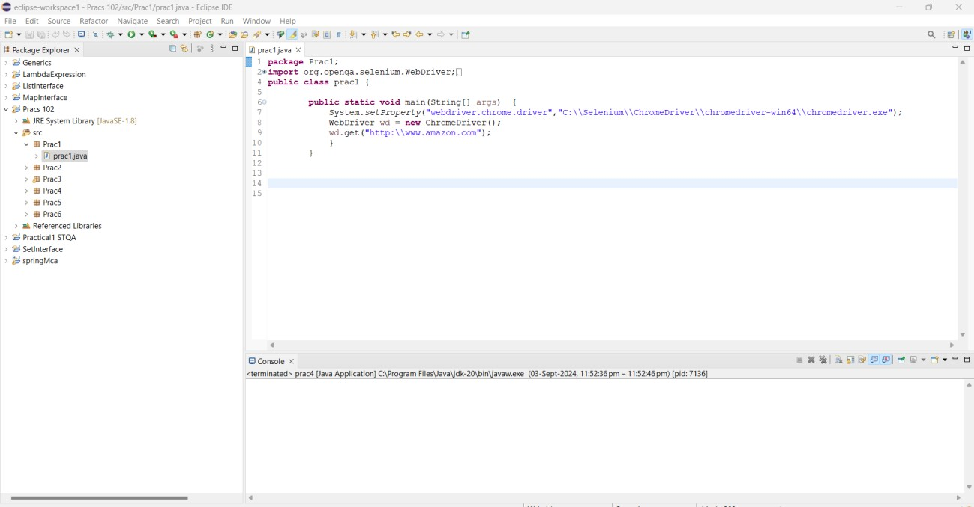

## Output:

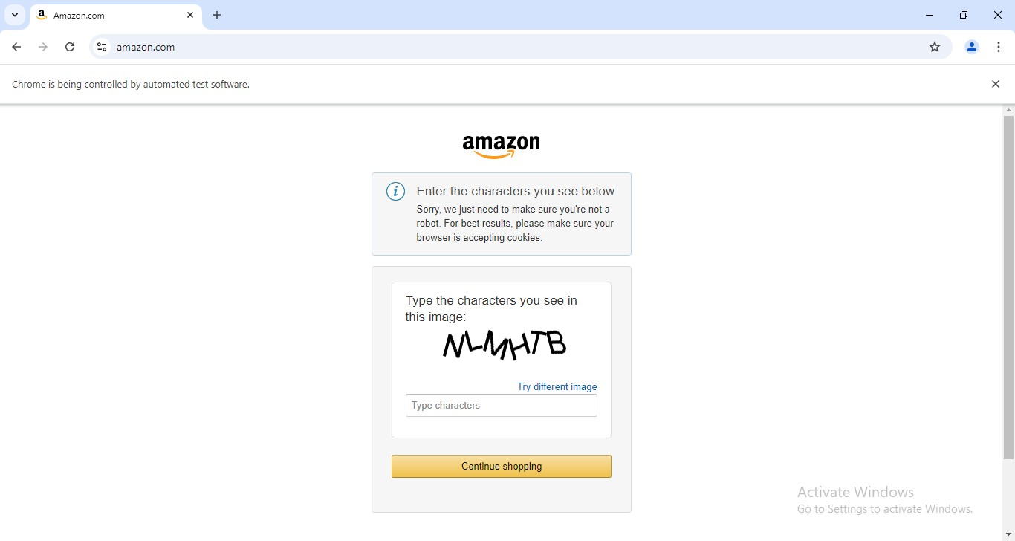

FireFox Browser

## Code:

package Prac1;

import org.openqa.selenium.WebDriver;

import org.openqa.selenium.firefox.FirefoxDriver; public class prac1a {

public static void main(String args[]) {

System.*setProperty*("webdriver.FireFox.driver","C:\\Selenium\\FirefoxDriver\\geckodr iver.exe");

WebDriver wd = new FirefoxDriver(); wd.get("[http://google.com"](http://google.com/));}}

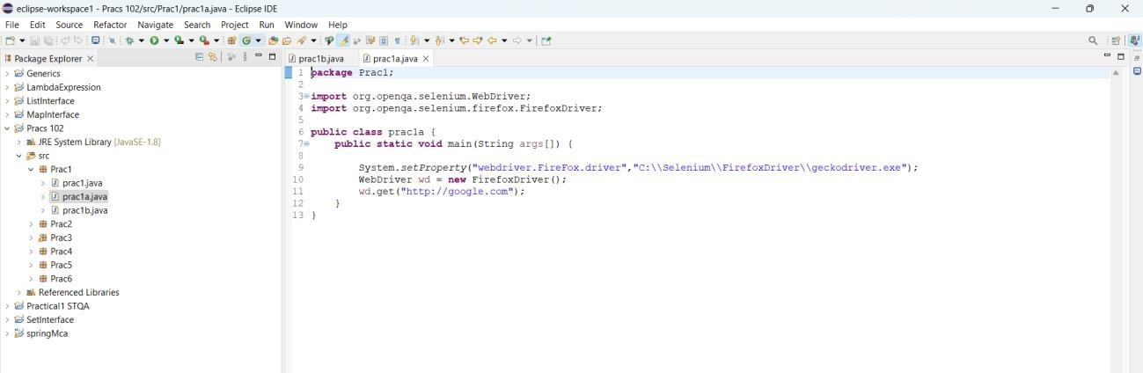

## Output:

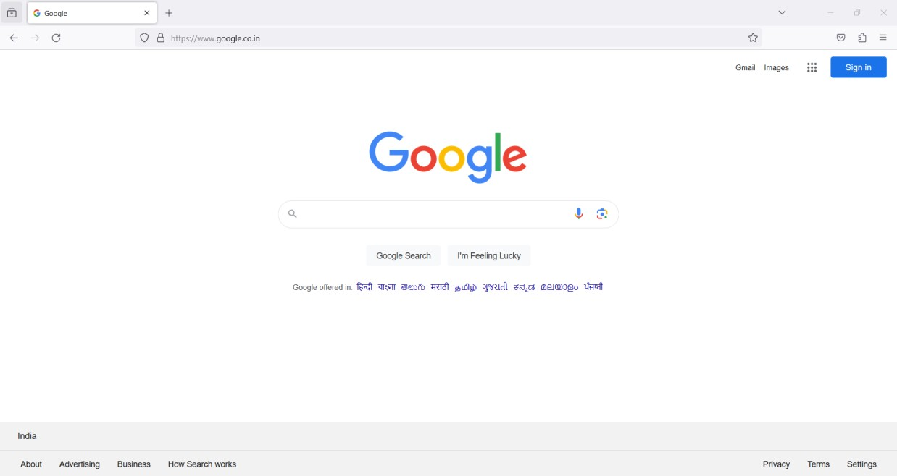

ChooseBrowser

## Code:

package Prac1;

import java.util.Scanner;

import org.openqa.selenium.WebDriver;

import org.openqa.selenium.chrome.ChromeDriver; import org.openqa.selenium.firefox.FirefoxDriver; public class prac1b {

static WebDriver *wd*;

public static void main(String[] args) { Scanner sc = new Scanner(System.*in*); System.*out*.println("Rollno 90");

System.*out*.println("1.Chrome \n 2.Firefox \n"); System.*out*.println("Choice:");

int ch = sc.nextInt(); sc.close();

switch (ch) {case 1:

System.*setProperty*("webdriver.chrome.driver","C:\\Selenium\\ChromeDriver\\chrome driver-win64\\chromedriver.exe");*wd* = new ChromeDriver();

break;case 2: System.*setProperty*("webdriver.FireFox.driver",

"C:\\Selenium\\FirefoxDriver\\geckodriver.exe");*wd* = new FirefoxDriver(); break;default:

System.*out*.println("Invalid Choice");

if (*wd* != null) {*wd*.get("[http://google.com"](http://google.com/));}}}}

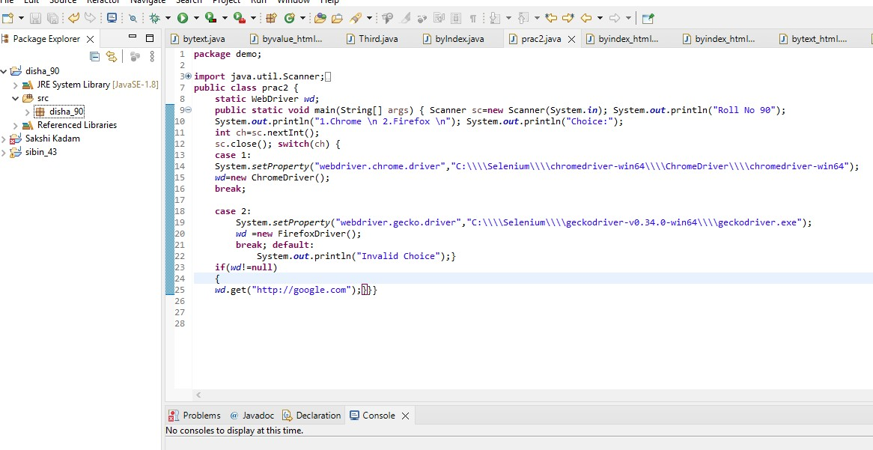

## Output:

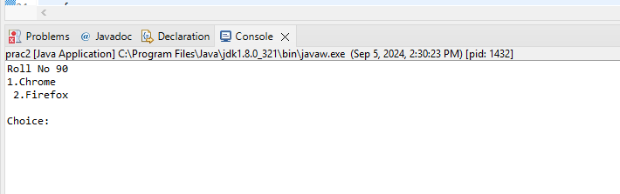

**Chrome Browser:**

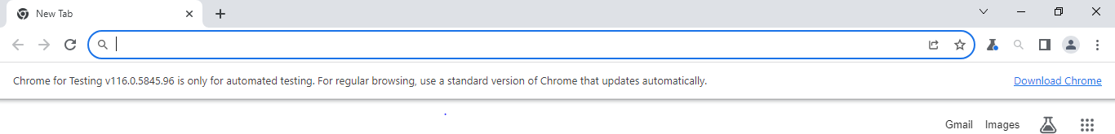

**Firefox Browser:**

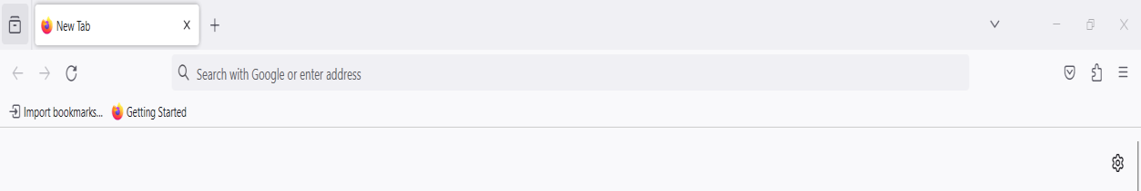

**Invalid Choice:**

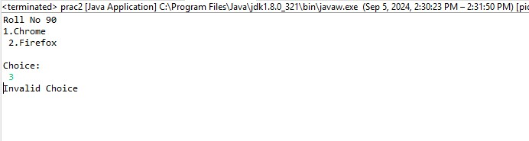

# Practiacal No 3

**Aim:- Demonstrate Handling multiple window in selenium.**

1. **Order Placed**

**package** disha_90;

**import** org.openqa.selenium.By;

**import** org.openqa.selenium.WebDriver;

**import** org.openqa.selenium.firefox.FirefoxDriver;

**import** org.openqa.selenium.support.ui.Select;

**import** org.openqa.selenium.support.ui.WebDriverWait;

**import** org.openqa.selenium.support.ui.ExpectedConditions;

//import org.openqa.selenium.support.ui.Duration;

**import** java.time.Duration;

**public** **class** orderplace {

**public** **static** **void** main(String[] args) {

        System.*setProperty*("webdriver.chrome.driver", "C:\\selenium web driver\\ChromeDriver\\chromedriver-win64\\geckodriver.exe");

        WebDriver wd = **new** FirefoxDriver();

        wd.get("https://demo.frontaccounting.eu/");

        WebDriverWait wait = **new** WebDriverWait(wd, Duration.*ofSeconds*(10));

        wait.until(ExpectedConditions.*visibilityOfElementLocated*(By.*name*("user_name_entry_field"))).sendKeys("your_username");

        wait.until(ExpectedConditions.*visibilityOfElementLocated*(By.*name*("password"))).sendKeys("your_password");

        Select s = **new** Select(wd.findElement(By.*name*("company_login_name")));

        wd.findElement(By.*name*("SubmitUser")).click();

        wait.until(ExpectedConditions.*elementToBeClickable*(By.*xpath*("/html/body/table[1]/tbody/tr/td/table[1]/tbody/tr/td/div[2]/table/tbody/tr[1]/td/table/tbody/tr[2]/td[1]/a[1]"))).click();

        Select sl = **new** Select(wd.findElement(By.*name*("customer_id")));

        sl.selectByVisibleText("Donald Easter");

        wd.findElement(By.*name*("AddItem")).click();

        wd.findElement(By.*name*("ProcessOrder")).click();

        wd.quit();

    }

}

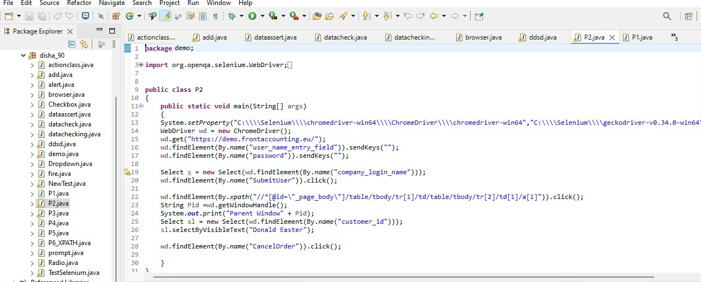

**Output:-**

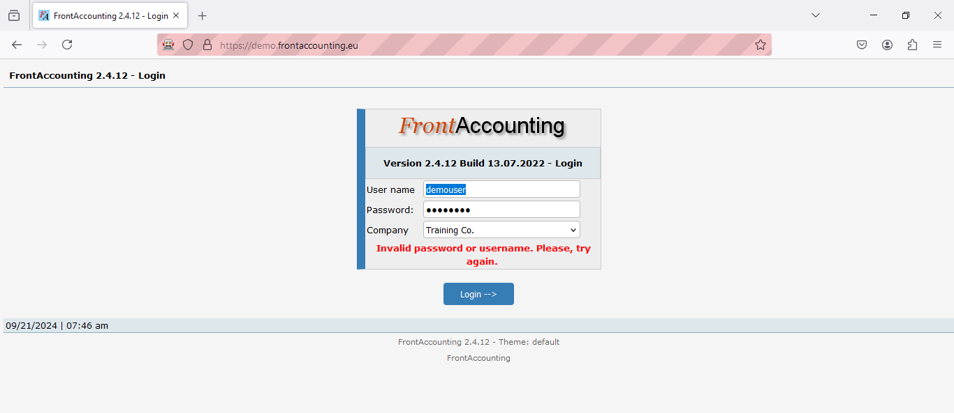

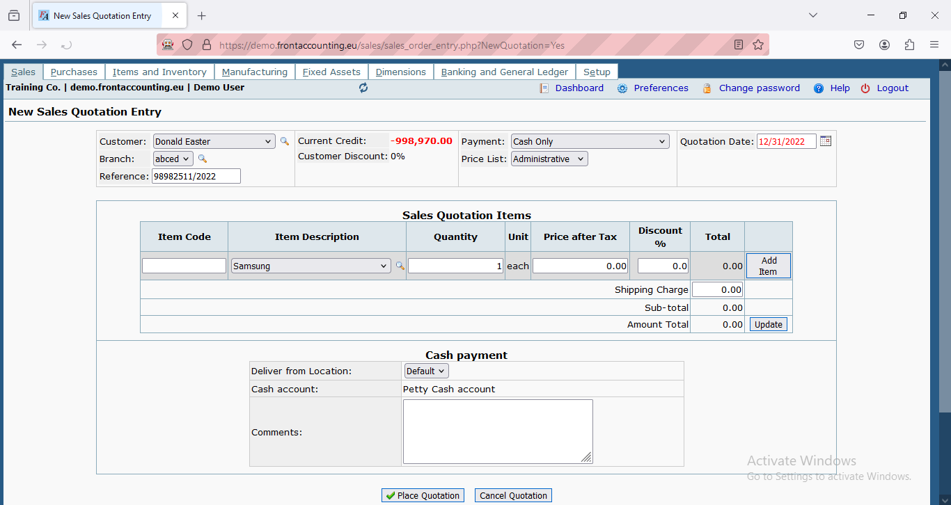

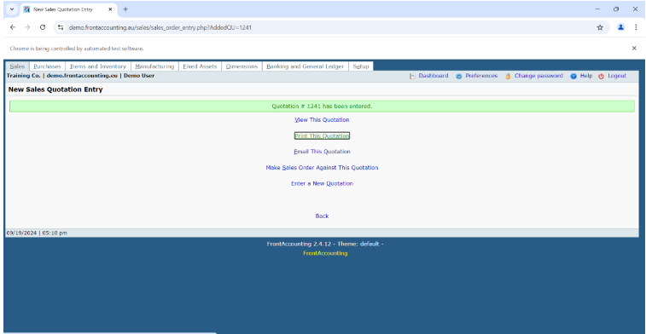

**2) Multiple Window Handling.**

**package** disha;

**import** java.util.Set;

**import** org.openqa.selenium.By;

**import** org.openqa.selenium.WebDriver;

**import** org.openqa.selenium.firefox.FirefoxDriver;

**import** org.openqa.selenium.support.ui.Select;

**public** **class** multiplewindowhandling {

**public** **static** **void** main(String[] args) {

System.*setProperty*("webdriver.chrome.driver", "C:\\selenium web driver\\ChromeDriver\\chromedriver-win64\\geckodriver.exe");

WebDriver wd = **new** FirefoxDriver();

wd.get("https://demo.frontaccounting.eu/");

wd.findElement(By.*name*("user_name_entry_field")).sendKeys("your_username"); // Add username

wd.findElement(By.*name*("password")).sendKeys("your_password"); // Add password

Select s = **new** Select(wd.findElement(By.*name*("company_login_name")));

wd.findElement(By.*name*("SubmitUser")).click();

wd.findElement(By.*xpath*("/html/body/table[1]/tbody/tr/td/table[1]/tbody/tr/td/div[2]/table/tbody/tr[1]/td/table/tbody/tr[2]/td[1]/a")).click();

String Pid = wd.getWindowHandle();

System.***out***.println("Parent Window > " + Pid);

wd.findElement(By.*xpath*("/html/body/table[1]/tbody/tr/td/table[1]/tbody/tr/td/div[2]/form/center[1]/table/tbody/tr/td[2]/table/tbody/tr[1]/td[2]/a")).click();

Set<String> allwin = wd.getWindowHandles();

**for** (String W : allwin) {

wd.switchTo().window(W);

System.***out***.println(wd.getTitle());

**if** (!W.equals(Pid)) {

Select ss = **new** Select(wd.findElement(By.*id*("customer_id"))); // Ensure the ID is correct

ss.selectByVisibleText("Donald Easter");

wd.manage().window().maximize();

wd.close(); // Close this window after processing

}

}

wd.switchTo().window(Pid);

wd.findElement(By.*linkText*("Logout")).click(); // Corrected syntax

}

}

Output:-

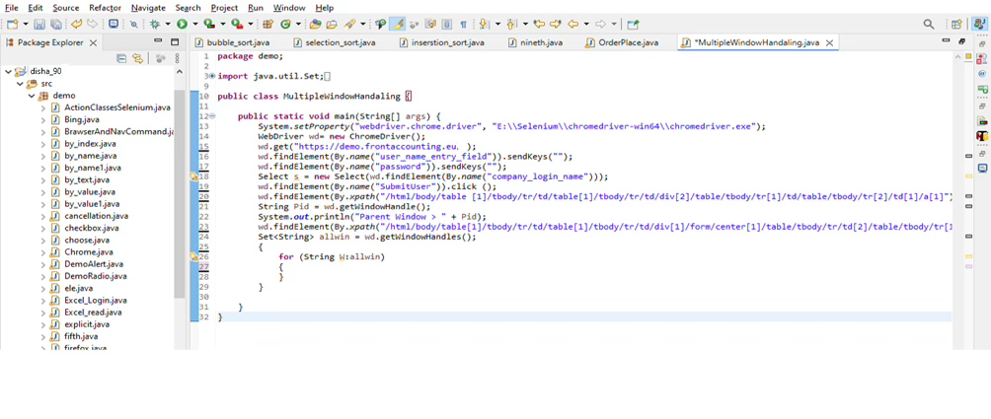



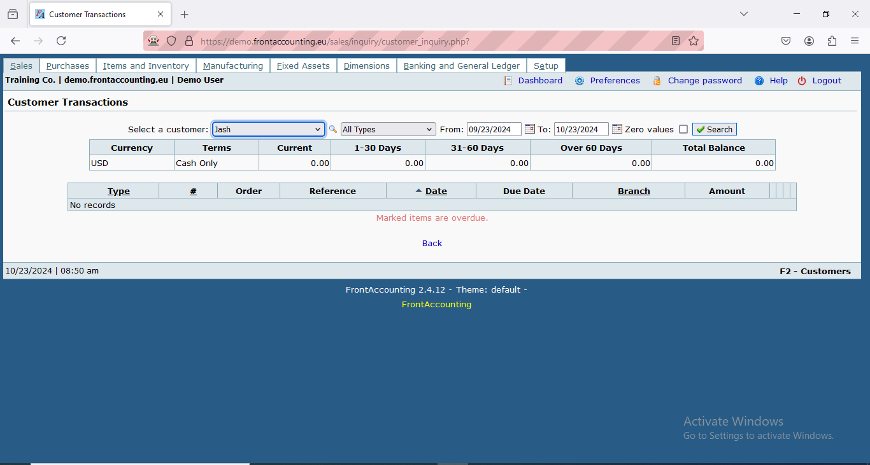

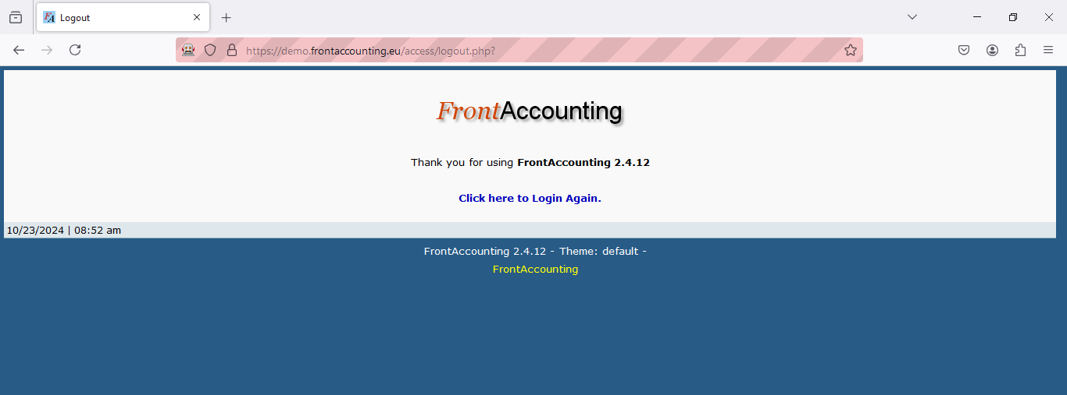

# Practical No 4

**Aim:- Implement Browser command and navigation commands**

**package** disha_90;

**import** org.openqa.selenium.By;

**import** org.openqa.selenium.WebDriver;

**import** org.openqa.selenium.firefox.FirefoxDriver;

**public** **class** practical {

**public** **static** **void** main(String[] args) **throws** Exception

{

System.*setProperty*("webdriver.chrome.driver","C:\\selenium web driver\\ChromeDriver\\chromedriver-win64\\chromedriver-win64\\geckodriver.exe");

WebDriver wd = **new** FirefoxDriver();

wd.get("https://opensource-demo.orangehrmlive.com/");

Thread.*sleep*(3000);

wd.findElement(By.*name*("username")).sendKeys("admin");

wd.findElement(By.*name*("password")).sendKeys("admin123");

wd.findElement(By.*xpath*("//*[@id=\"app\"]/div[1]/div/div[1]/div/div[2]/div[2]/form/div[3]/button")).click();

Thread.*sleep*(2000);

wd.navigate().back();

Thread.*sleep*(2000);

wd.navigate().forward();

wd.navigate().to("https://opensource-demo.orangehrmlive.com/");

wd.navigate().refresh();

}

}

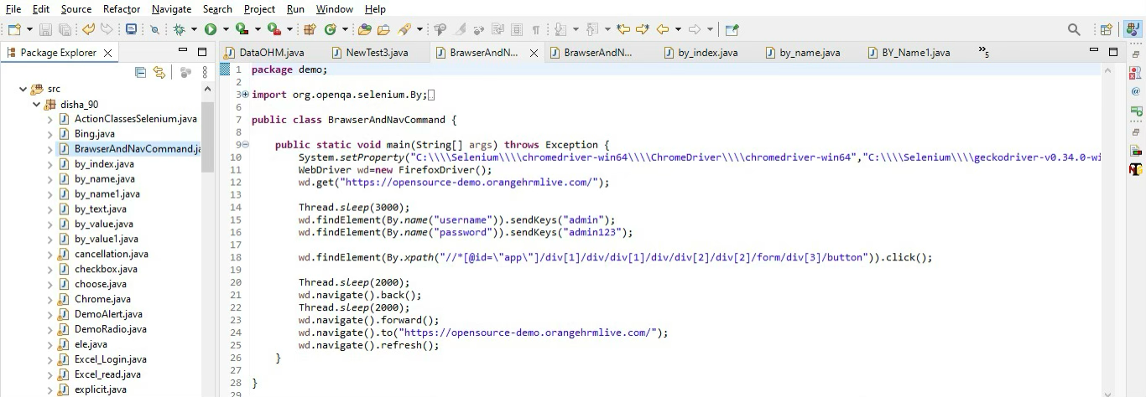

Output:-

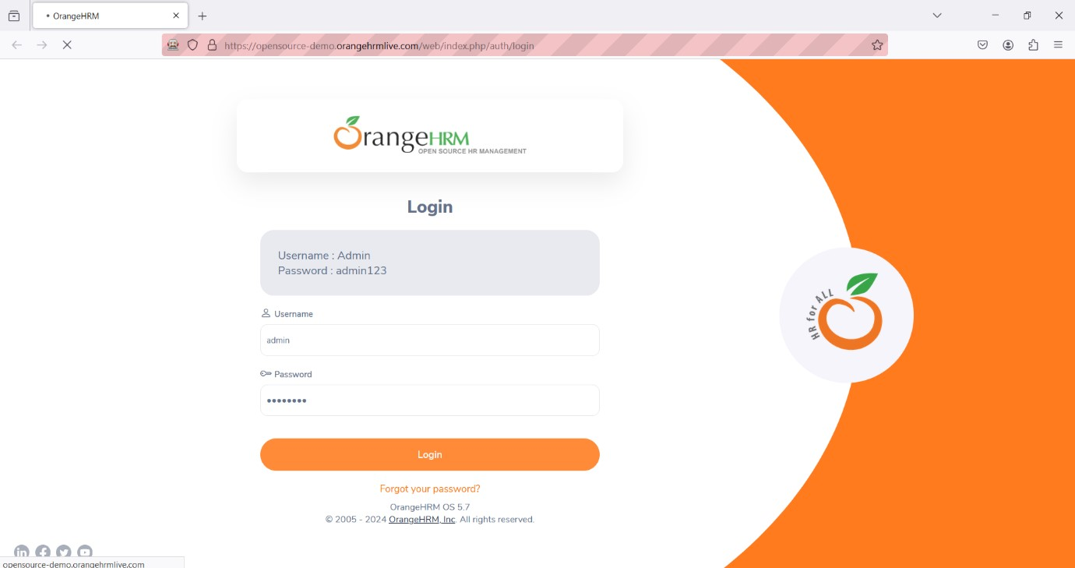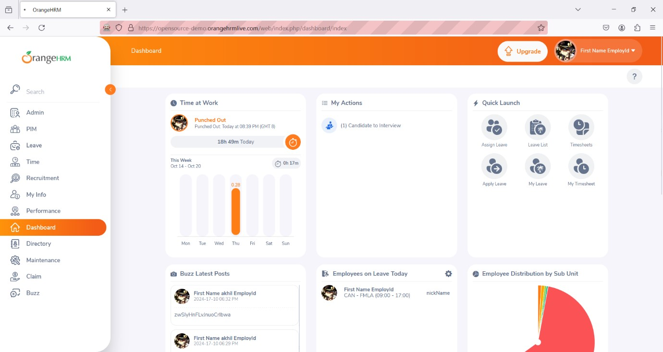

**Practical No 5**

**AIM: Implement the find element command.**

**CODE:**

package disha_90;

import org.openqa.selenium.By;

import org.openqa.selenium.WebDriver;

import org.openqa.selenium.firefox.FirefoxDriver;

public class Practical4

{

public static void main(String[] args) throws Exception

{

System.setProperty("webdriver.chrome.driver","C:\\selenium web driver\\ChromeDriver\\chromedriver-win64\\chromedriver-win64\\geckodriver.exe");

WebDriver wd = new FirefoxDriver();

wd.get("https://opensource-demo.orangehrmlive.com/");

        Thread.sleep(5000);

wd.findElement(By.xpath("/html/body/div/div[1]/div/div[1]/div/div[2]/div[2]/form/div[1]/div/div[2]/input")).sendKeys("admin");

wd.findElement(By.xpath("/html/body/div/div[1]/div/div[1]/div/div[2]/div[2]/form/div[2]/div/div[2]/input")).sendKeys("admin123");

wd.findElement(By.xpath("/html/body/div/div[1]/div/div[1]/div/div[2]/div[2]/form/div[3]/button")).click();

}

}

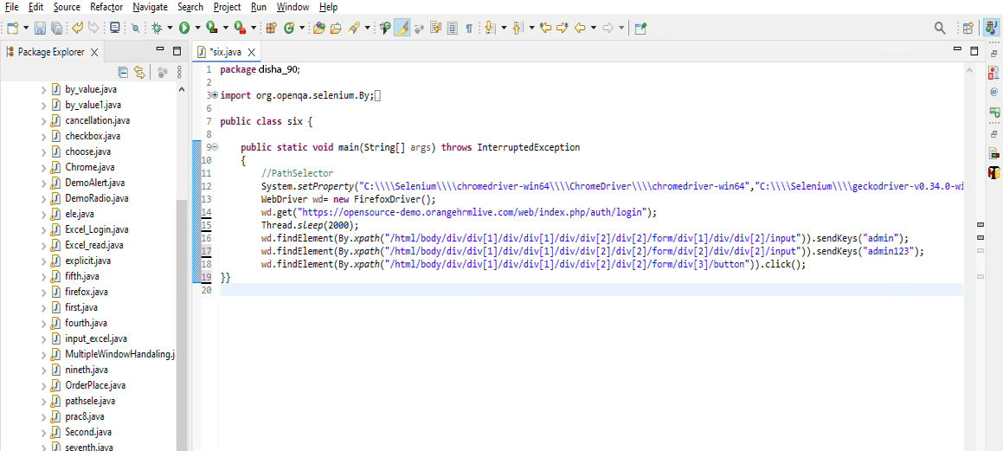

Output:-

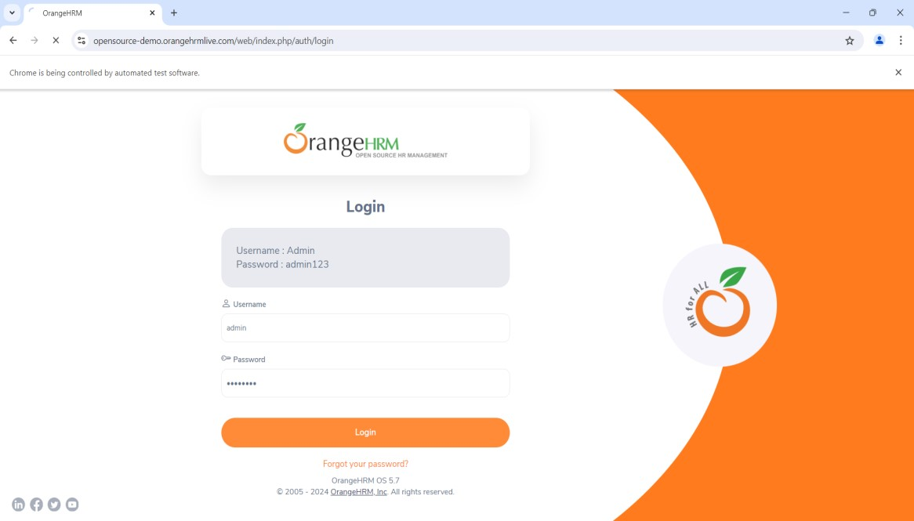

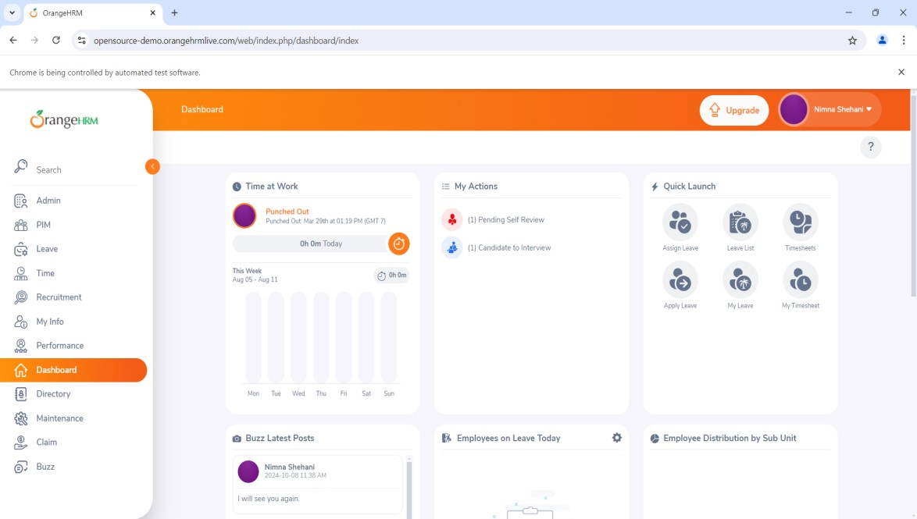

# Practical No 6

**Aim:** Demonstrate the locator(byname,CssSelector, Xpath,path)

**byname Code:**

package Prac2;

import org.openqa.selenium.By;

import org.openqa.selenium.WebDriver;

import org.openqa.selenium.firefox.FirefoxDriver; public class prac2 {

public static void main(String[] args) throws Exception { System.setProperty("webdriver.chrome.driver","C:\\Selenium\\FirefoxDriver\\geckodriver.exe"); WebDriver wd = new FirefoxDriver();

wd.get("https://opensource-demo.orangehrmlive.com/"); Thread.sleep(2000);

wd.findElement(By.xpath("//*[@id=\"app\"]/div[1]/div/div[1]/div/div[2]/div[2]/form/input")).sendKeys("ad min"); wd.findElement(By.xpath("//*[@id=\"app\"]/div[1]/div/div[1]/div/div[2]/div[2]/form/input")).sendKeys("ad min123"); wd.findElement(By.xpath("//*[@id=\"app\"]/div[1]/div/div[1]/div/div[2]/div[2]/form/div[3]/button")).click();

}

}

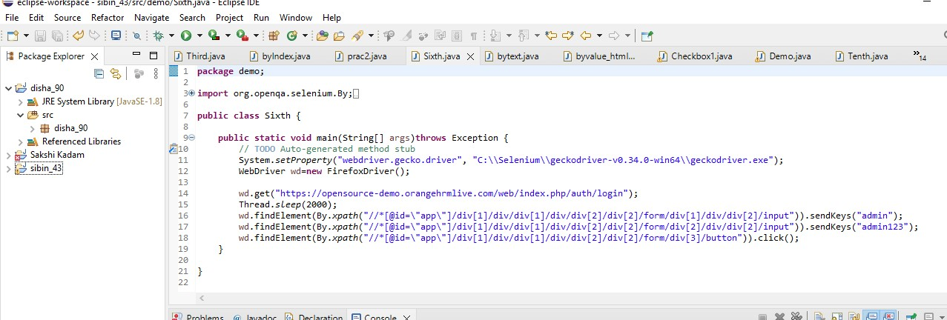

## Output:

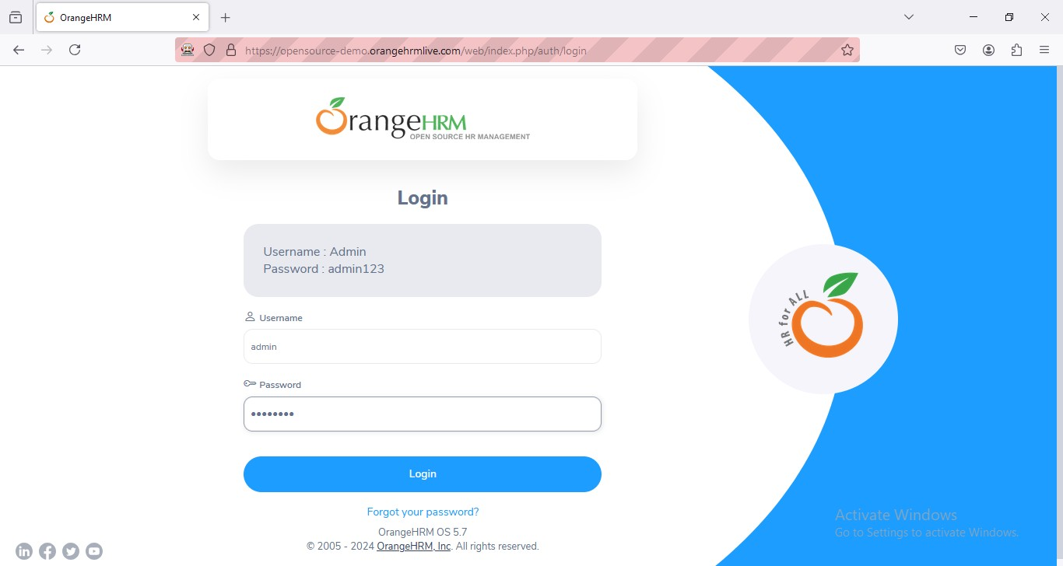

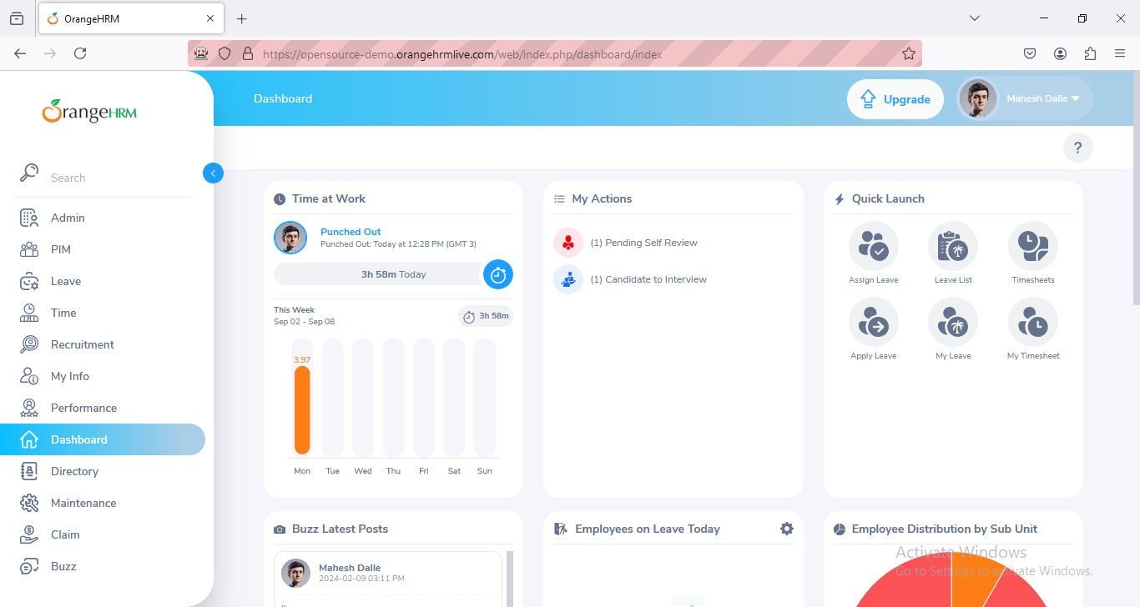

**Xfullpath Code:**

package Prac2;

import org.openqa.selenium.By;

import org.openqa.selenium.WebDriver;

import org.openqa.selenium.firefox.FirefoxDriver; public class prac2a {

public static void main(String[] args) throws Exception { System.setProperty("webdriver.chrome.driver",

"C:\\Selenium\\FirefoxDriver\\geckodriver.exe");

WebDriver wd = new FirefoxDriver(); wd.get("https://opensource-demo.orangehrmlive.com/"); Thread.sleep(2000);

wd.findElement(By.xpath("/html/body/div/div[1]/div/div[1]/div/div[2]/div[2]/div/div/p[1]")).sendKey s("Admin");

wd.findElement(By.xpath("/html/body/div/div[1]/div/div[1]/div/div[2]/div[2]/div/div/p[2]")).sendKey s("admin123");

wd.findElement(By.xpath("/html/body/div/div[1]/div/div[1]/div/div[2]/div[2]/form/div[3]/button")).cl

ick();

}

}



## Output:

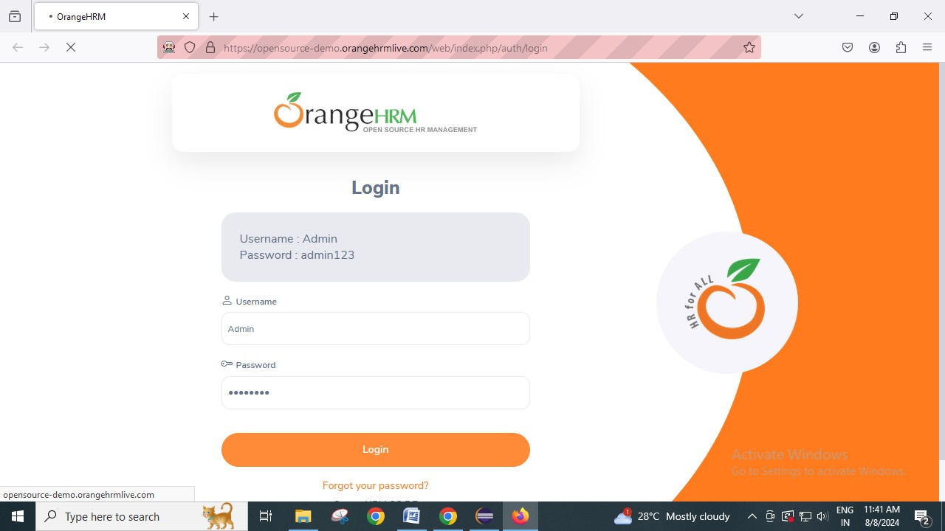

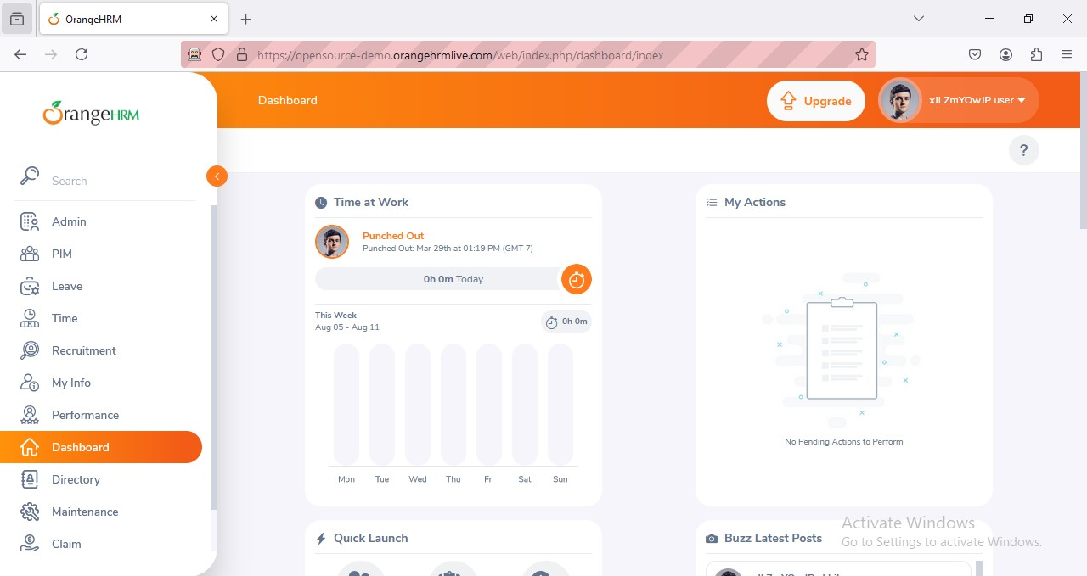

**CssSelector Code:**

package Prac2;

import org.openqa.selenium.By;

import org.openqa.selenium.WebDriver;

import org.openqa.selenium.chrome.ChromeDriver; public class prac2b {

public static void main(String[] args) throws Exception { System.*setProperty*("webdriver.gecko.driver",

"C:\\Selenium\\FirefoxDriver\\geckodriver.exe");

WebDriver wd = new ChromeDriver(); wd.get("https://opensource-demo.orangehrmlive.com"); Thread.*sleep*(2000);

wd.findElement(By.*cssSelector*("input[name=username]")).sendKeys("admin"); wd.findElement(By.*cssSelector*("input[name=password]")).sendKeys("admin123");

wd.findElement(By.*cssSelector*("button[type=Submit]")).click();

}

}

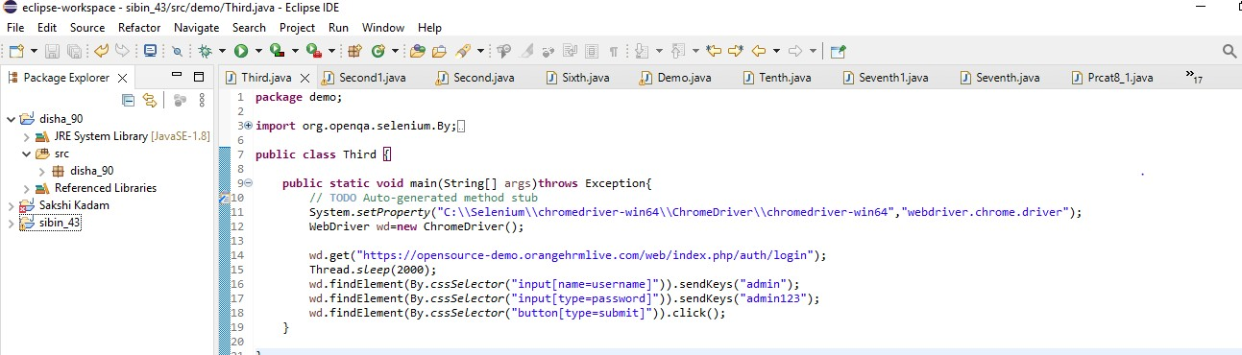

**Output:**

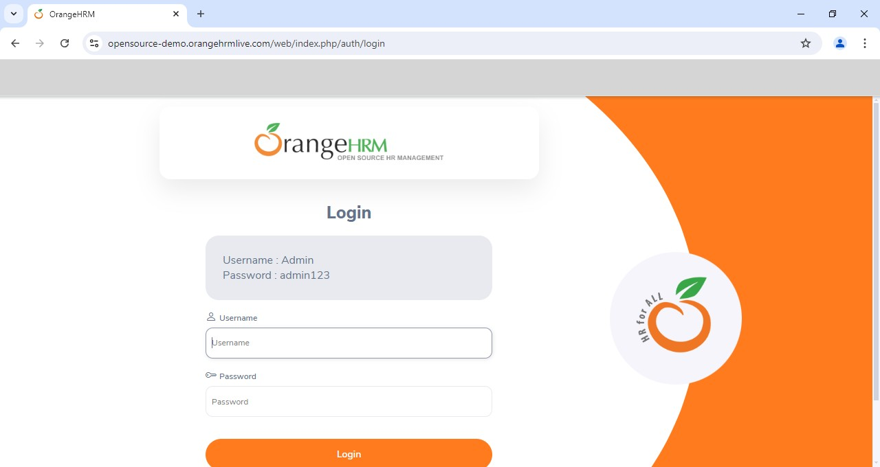

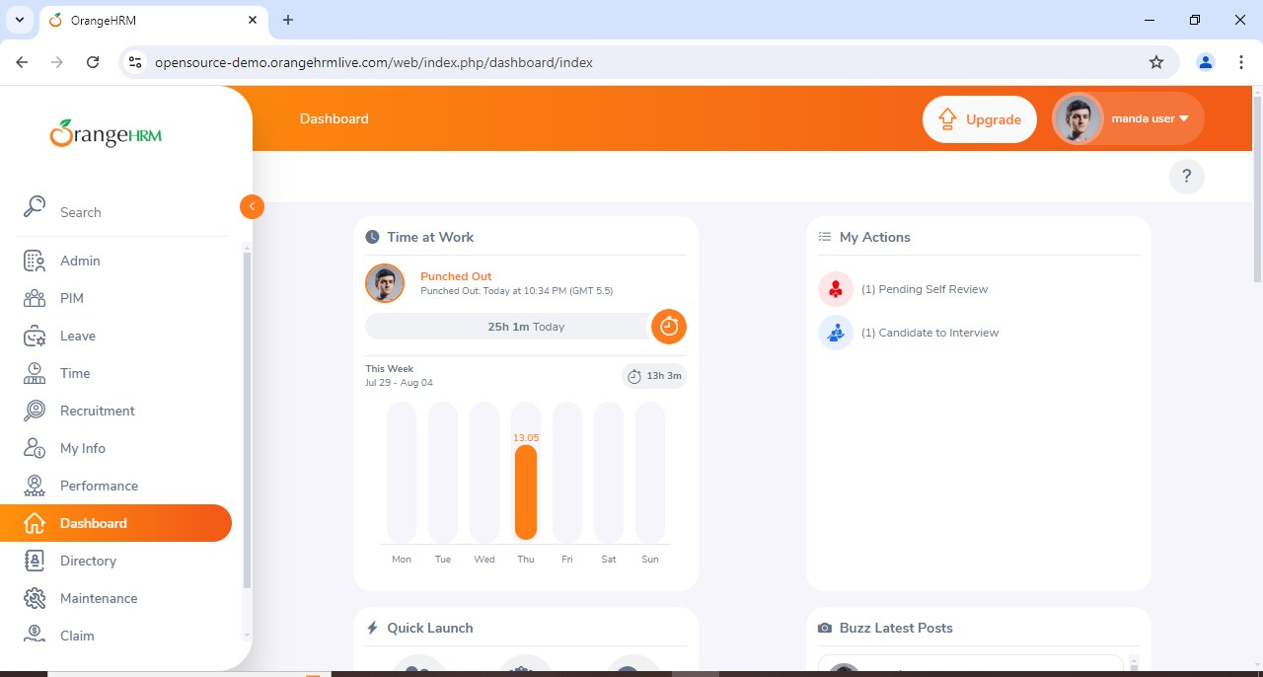

# Practical No 7

**Aim:** Demonstrate Synchronization in selenium (Implicitly wait, explicitly wait)

**Implicitly wait Code:**

package Prac3;

import java.util.concurrent.TimeUnit; import org.openqa.selenium.By;

import org.openqa.selenium.WebDriver;

import org.openqa.selenium.chrome.ChromeDriver; public class prac3 {

public static void main(String[] args) { System.*setProperty*("webdriver.chrome.driver","C:\\Selenium\\ChromeDriver\\chromedriver-

win64\\chromedriver.exe");

WebDriver wd = new ChromeDriver(); wd.get("https://opensource-demo.orangehrmlive.com/"); wd.manage().timeouts().implicitlyWait(10, TimeUnit.*SECONDS*);

wd.findElement(By.*name*("Username")).sendKeys("Admin");// locator id wd.findElement(By.*name*("Password")).sendKeys("Admin123");// locator name wd.findElement(By.*className*("oxd-button")).click();// locator classname

}

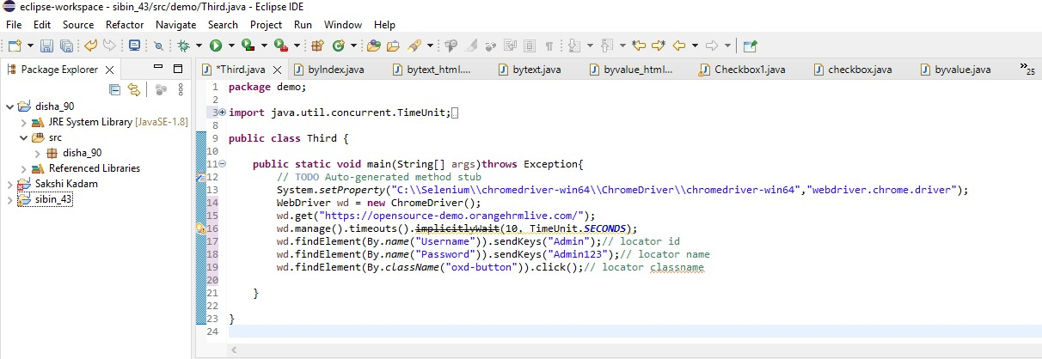}

## Output:

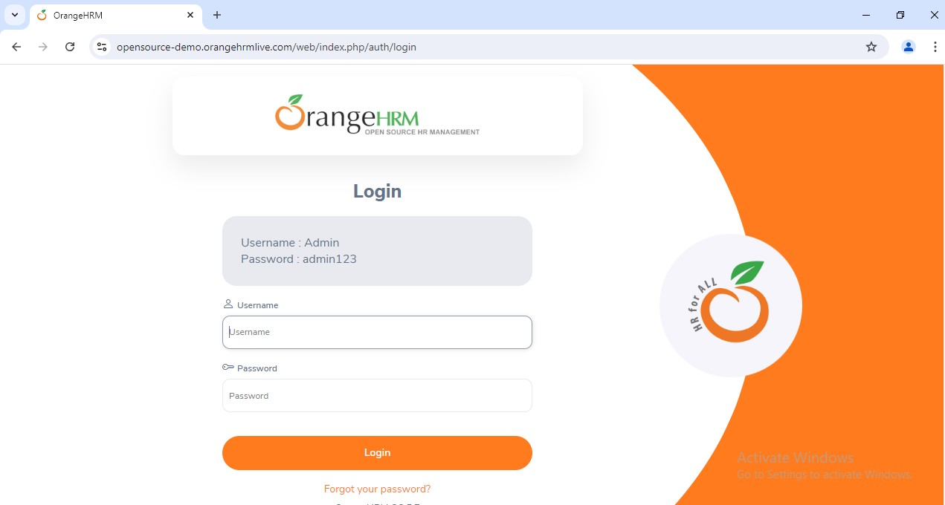

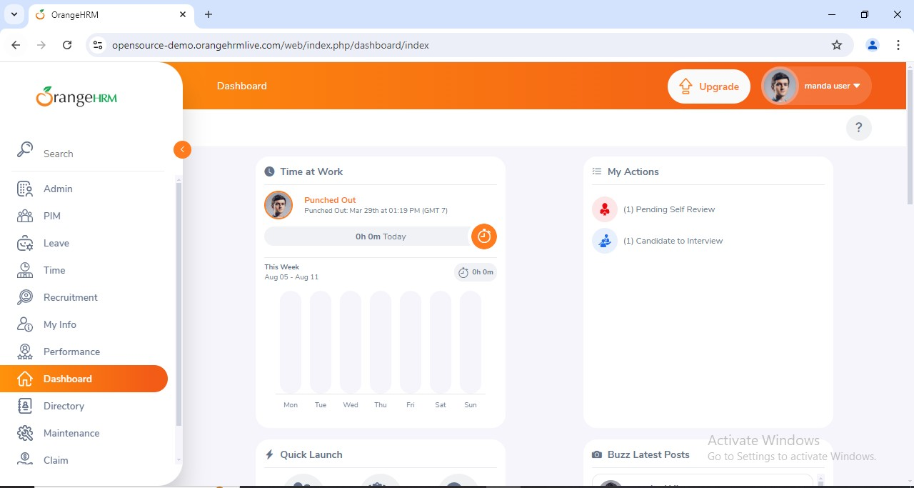

**Explicitly wait Code:**

package Prac3;

import java.time.Duration; import org.openqa.selenium.By;

import org.openqa.selenium.WebDriver;

import org.openqa.selenium.firefox.FirefoxDriver;

import org.openqa.selenium.support.ui.ExpectedConditions; import org.openqa.selenium.support.ui.WebDriverWait; public class prac3a {

public static void main(String[] args) { System.*setProperty*("webdriver.chrome.driver","C:\\Selenium\\ChromeDriver\\chromedriver-

win64\\chromedriver.exe");

WebDriver wd = new FirefoxDriver(); wd.get("https://opensource-demo.orangehrmlive.com/");

WebDriverWaitwt = new WebDriverWait(wd, Duration.*ofSeconds*(30)); wt.until(ExpectedConditions.*visibilityOfElementLocated*(By.*name*("Username"))).sendKeys("admin"); wt.until(ExpectedConditions.*visibilityOfElementLocated*(By.*name*("Password"))).sendKeys("admin123"); wt.until(ExpectedConditions.*elementToBeClickable*(By.*className*("oxd-button"))).click(); wt.until(ExpectedConditions.*elementToBeClickable*(By.*className*("oxd-userdropdown-tab"))).click(); wt.until(ExpectedConditions.*elementToBeClickable*(By.*partialLinkText*("Logout"))).click();

}

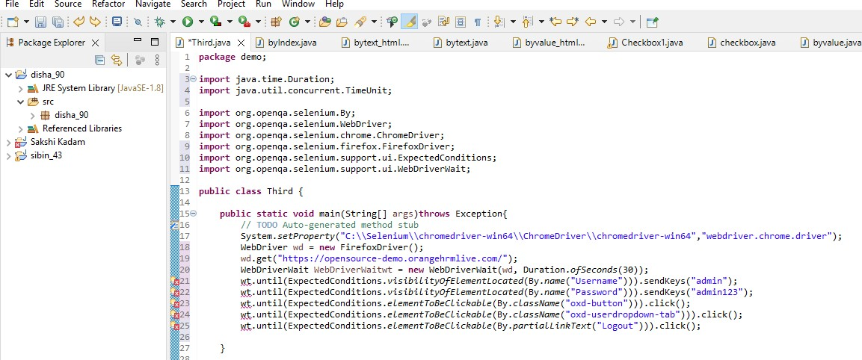}

**Output:**

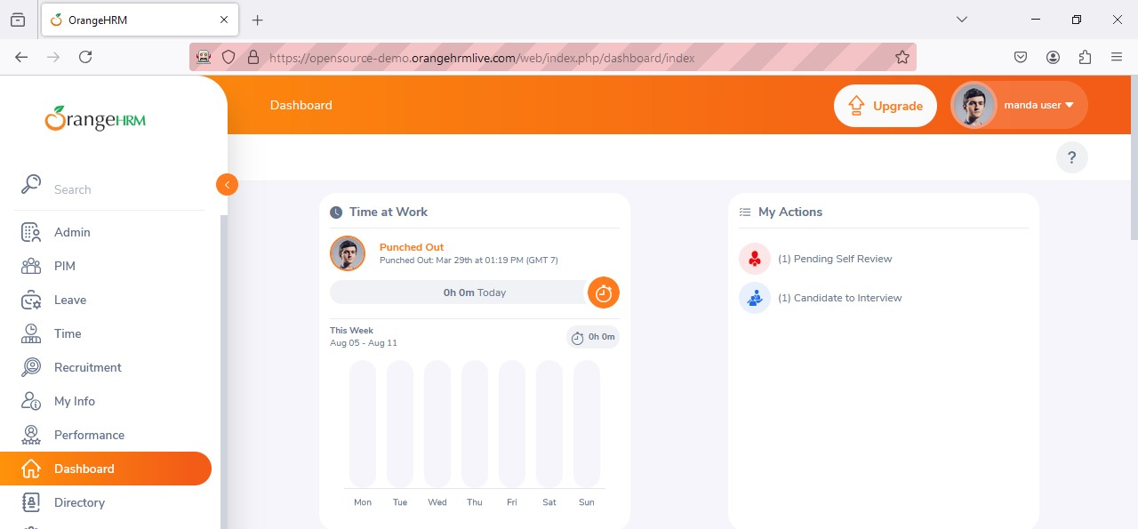

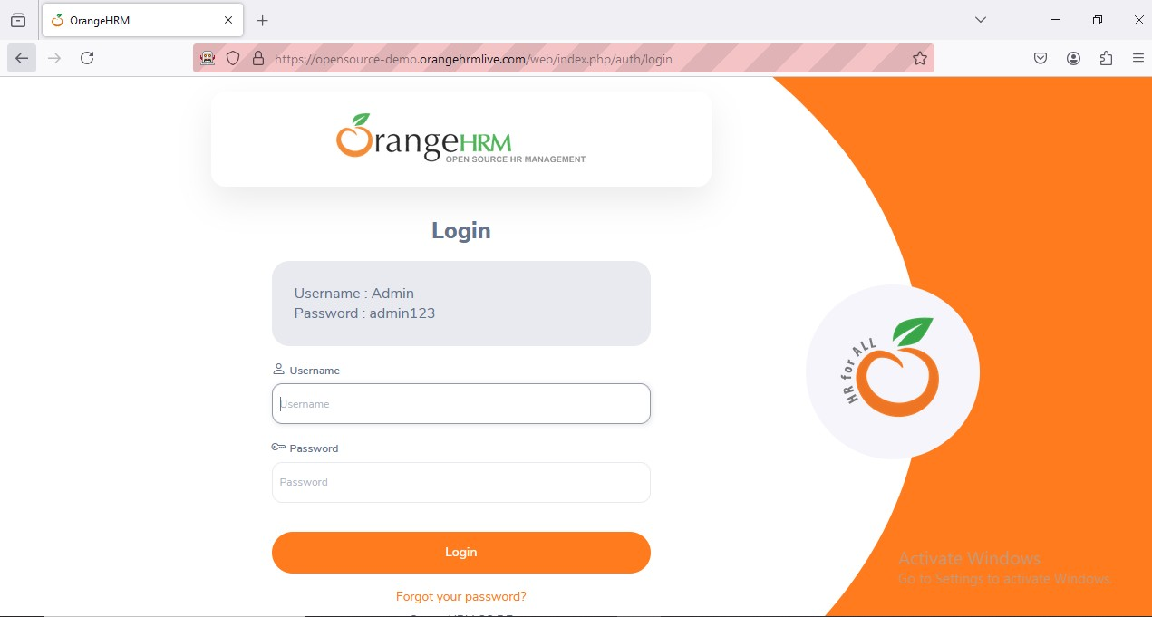

# Practical No 8

**Aim:- Demonstrate Different types of alerts.**

**package** disha_90;

**import** org.openqa.selenium.By;

**import** org.openqa.selenium.WebDriver;

**import** org.openqa.selenium.chrome.ChromeDriver;

**import** org.openqa.selenium.firefox.FirefoxDriver;

**import** org.openqa.selenium.support.ui.Select;

**public** **class** alert {

**public** **static** **void** main(String[] args)

{

System.*setProperty*("webdriver.chrome.driver","C:\\selenium web driver\\ChromeDriver\\chromedriver-win64\\chromedriver-win64\\geckodriver.exe");

WebDriver wd = **new** FirefoxDriver();

wd.get("https://demo.frontaccounting.eu/");

wd.findElement(By.*name*("user_name_entry_field")).sendKeys("");

wd.findElement(By.*name*("password")).sendKeys("");

Select s = **new** Select(wd.findElement(By.*name*("company_login_name")));

wd.findElement(By.*name*("SubmitUser")).click();

wd.findElement(By.*xpath*("/html/body/table[1]/tbody/tr/td/table[1]/tbody/tr/td/div[2]/table/tbody/tr[1]/td/table/tbody/tr[2]/td[1]/a[1]")).click();

String Pid = wd.getWindowHandle();//getting id of current page

System.***out***.println("Parent Window > " + Pid);

Select s1 = **new** Select(wd.findElement(By.*name*("customer_id")));

s1.selectByVisibleText("Donald Easter");

wd.findElement(By.*name*("CancelOrder")).click();

}

}

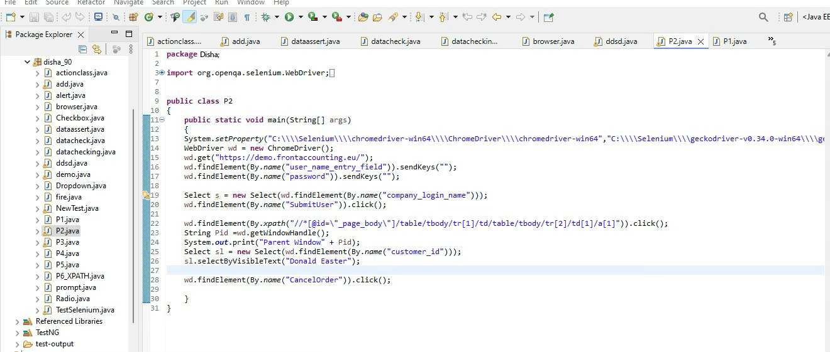

Output:-

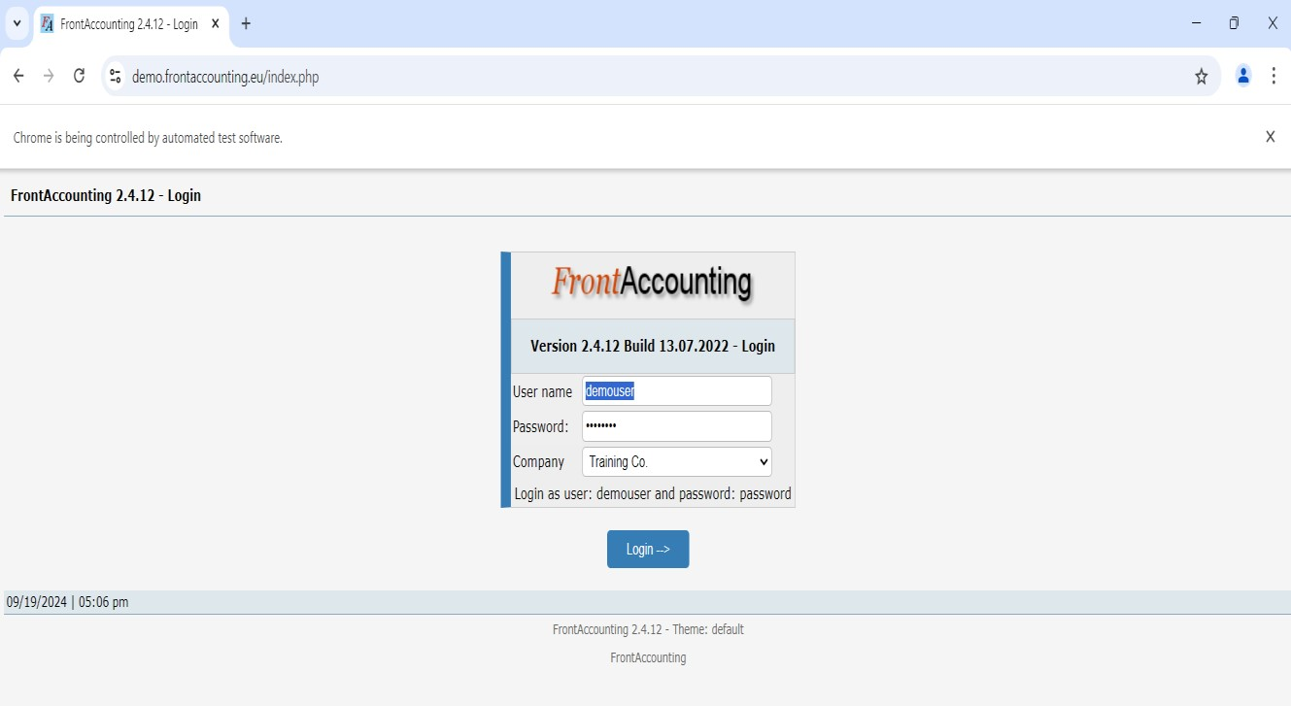

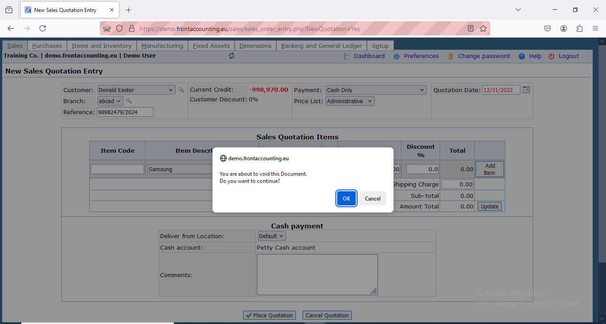

# Practical No 9

**Aim:**Demonstrate handling drop down, list (ByIndex, ByText, ByValue)

**By text Code:**

package Prac4;

import org.openqa.selenium.By;

import org.openqa.selenium.WebDriver;

import org.openqa.selenium.firefox.FirefoxDriver; import org.openqa.selenium.support.ui.Select; public class prac4 {

public static void main(String[] args) throws Exception { System.*setProperty*("webDriver.gecko.driver","C:\\Selenium\\FirefoxDriver\\geckodriver.exe");

WebDriver wd = new FirefoxDriver(); wd.get("https://blazedemo.com/"); Thread.*sleep*(2000);

Select s = new Select(wd.findElement(By.*name*("fromPort"))); s.selectByVisibleText("Paris");

}

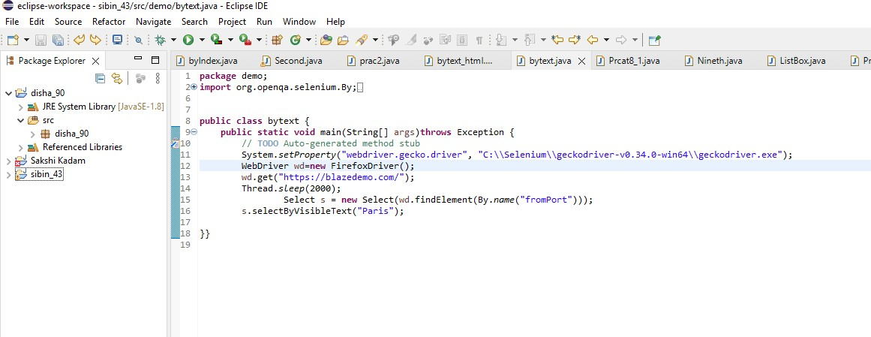}

## Output:

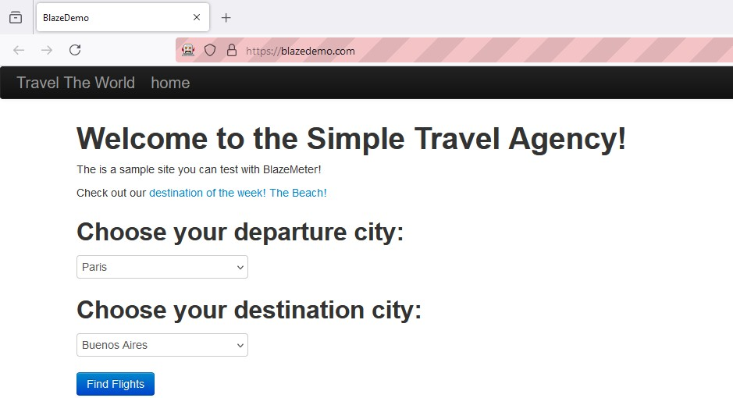

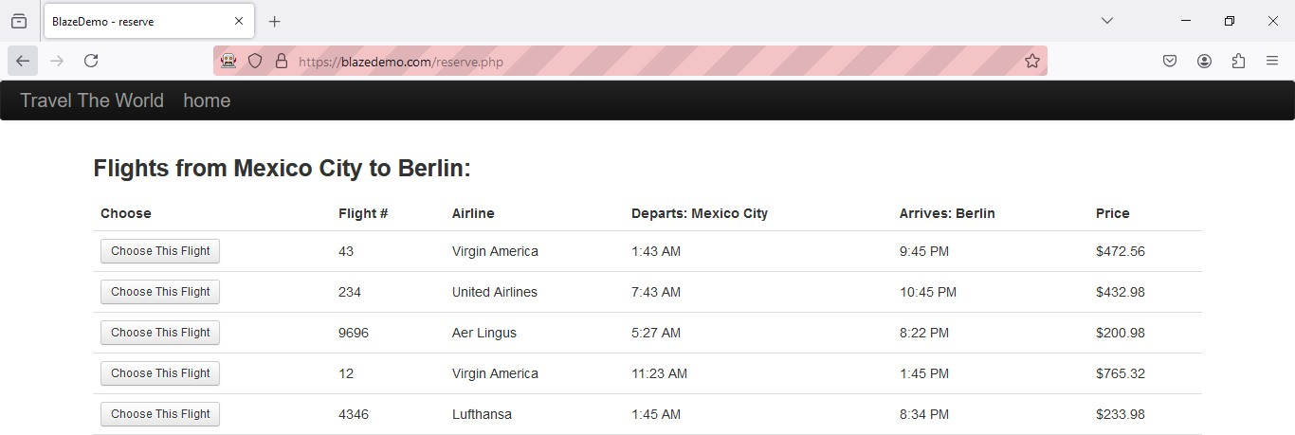

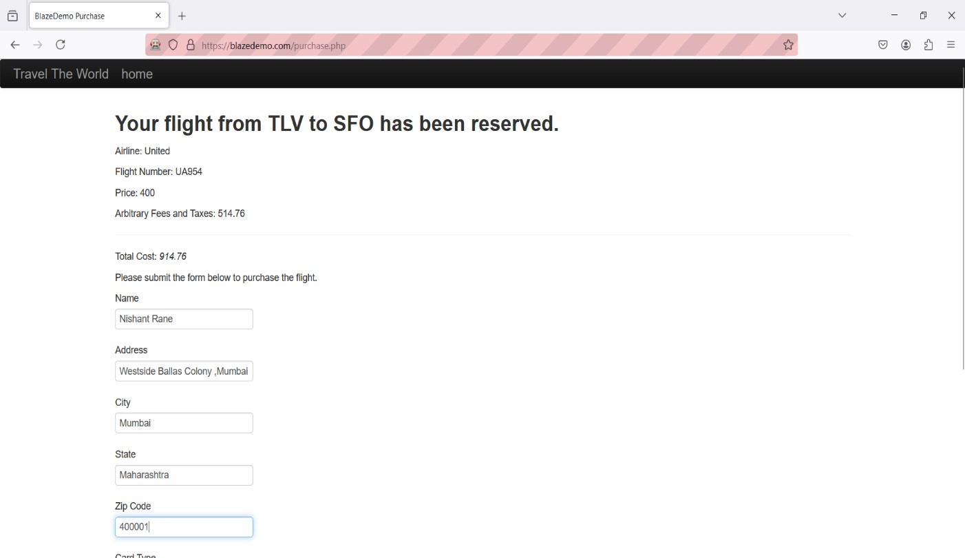

**By Value Code:**

package Prac4;

import org.openqa.selenium.By;

import org.openqa.selenium.WebDriver;

import org.openqa.selenium.firefox.FirefoxDriver; import org.openqa.selenium.support.ui.Select; public class prac4a {

public static void main(String[] args) throws Exception { System.*setProperty*("webDriver.gecko.driver", "C:\\Selenium\\FirefoxDriver\\geckodriver.exe");

WebDriver wd = new FirefoxDriver(); wd.get("https://blazedemo.com/"); Thread.*sleep*(2000);

Select s = new Select(wd.findElement(By.*name*("fromPort"))); s.selectByValue("Mexico City");

}

}

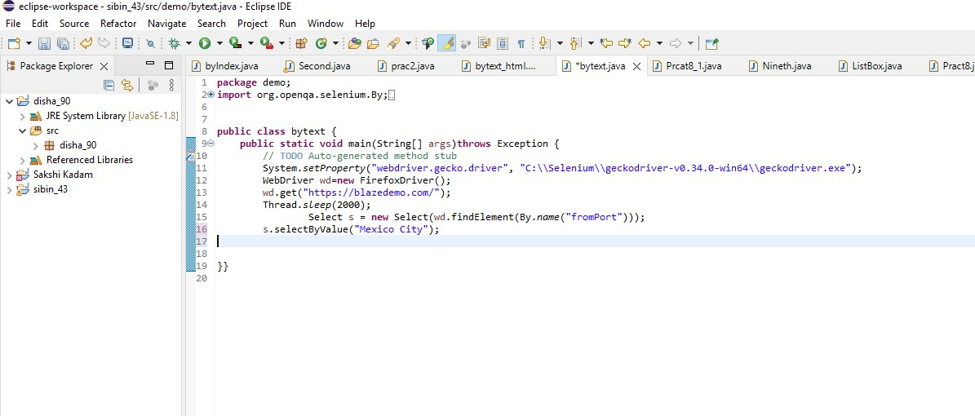

## Output:

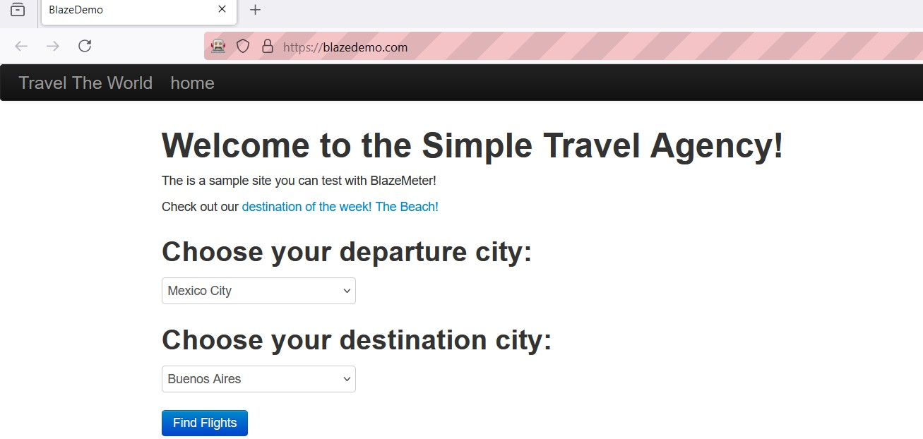

**By Index Code:**

package Prac4;

import org.openqa.selenium.By;

import org.openqa.selenium.WebDriver;

import org.openqa.selenium.firefox.FirefoxDriver; import org.openqa.selenium.support.ui.Select; public class prac4b {

public static void main(String[] args) throws Exception { System.setProperty("webDriver.gecko.driver", "C:\\Selenium\\FirefoxDriver\\geckodriver.exe");

WebDriver wd = new FirefoxDriver(); wd.get("https://blazedemo.com/"); Thread.sleep(2000);

Select s = new Select(wd.findElement(By.name("fromPort")));

//By index s.selectByIndex(3);

}

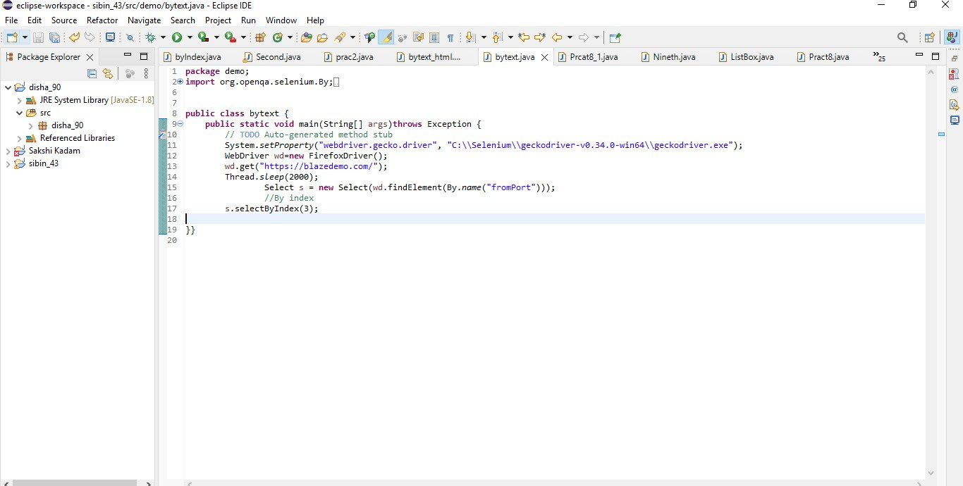}

## Output:

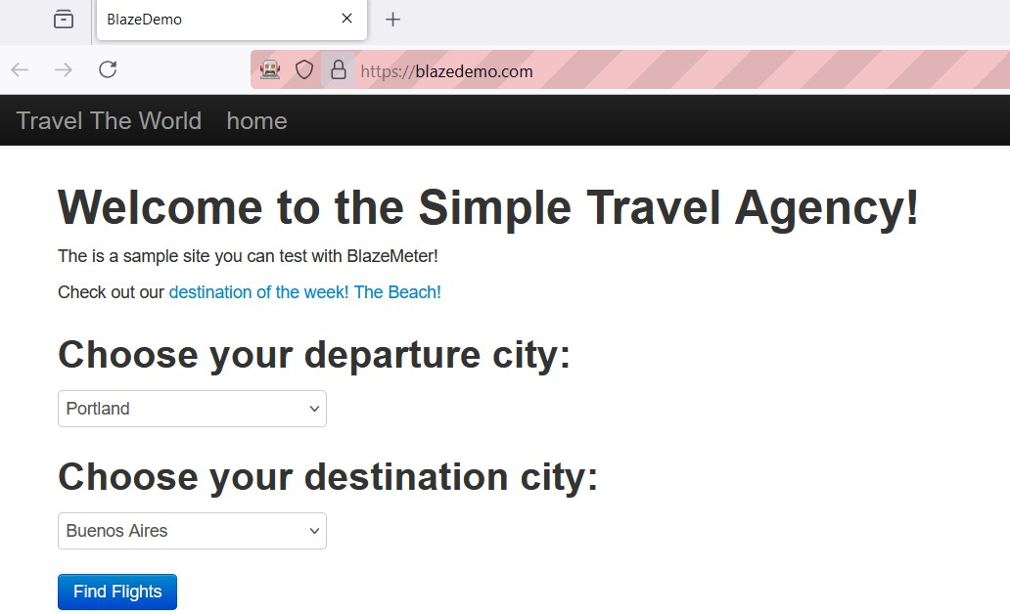

**Listbox:**

Cars.html

## Code:

<!DOCTYPE html>

<html lang="en">

<head>

<meta charset="UTF-8">

<meta http-equiv="X-UA-Compatible" content="IE=edge">

<meta name="viewport" content="width=device-width, initial-scale=1.0">

<title>DropdownList</title>

</head><body>

<h1>Dropdown List </h1>

<h2>Car Company'sToWatchOut</h2>

<select id="Cars" name="Cars" size="5" multiple style="font-size: x-large;">

<option value="1">Mercedes</option>

<option value="2">BMW</option>

<option value="3">Audi</option>

<option value="4">Jaguar</option>

<option value="5">Aston Martin</option>

</select></body></html>

**Output:**

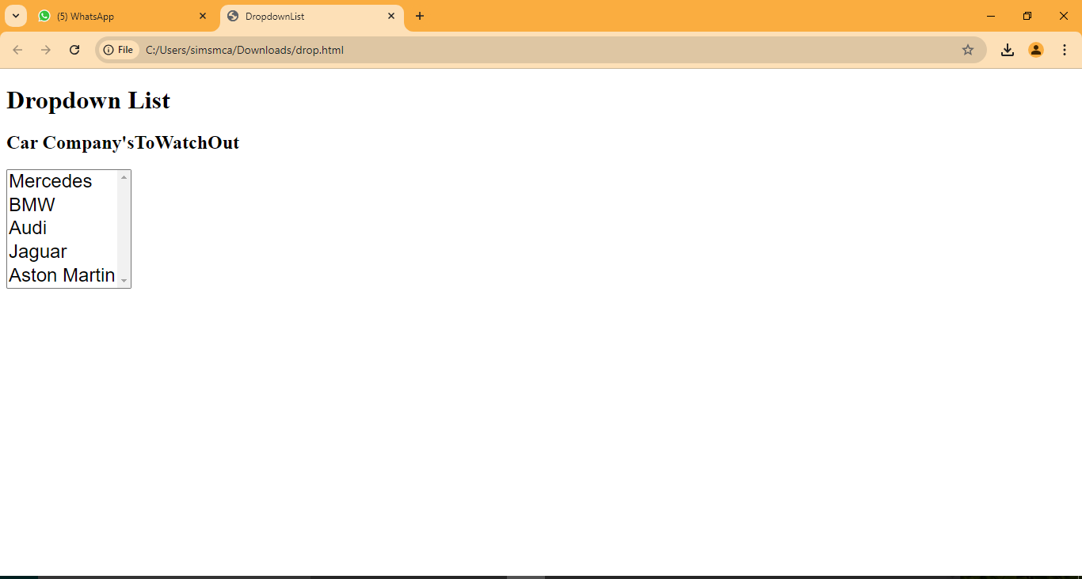

1. **Selecting one value usingIndex**

package Prac4;

import org.openqa.selenium.By;

import org.openqa.selenium.WebDriver;

import org.openqa.selenium.chrome.ChromeDriver; import org.openqa.selenium.support.ui.Select; public class prac41 {

public static void main(String[] args) throws Exception { System.*setProperty*("webdriver.chrome.driver","C:\\Selenium\\ChromeDriver\\chrome driver-win64\\chromedriver.exe");

WebDriver wd = new ChromeDriver(); wd.get("file:///D:/disha%20102/Cars.html"); Thread.*sleep*(2000);

Select s = new Select(wd.findElement(By.*id*("Cars"))); s.selectByIndex(1);}}

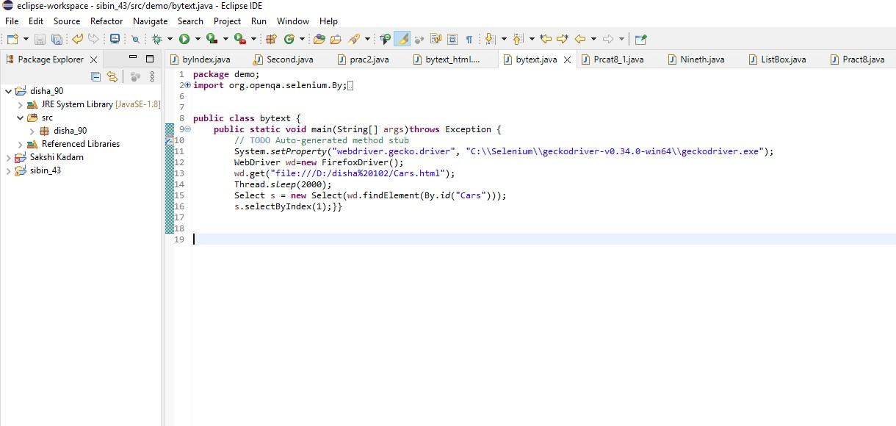

**Output:**

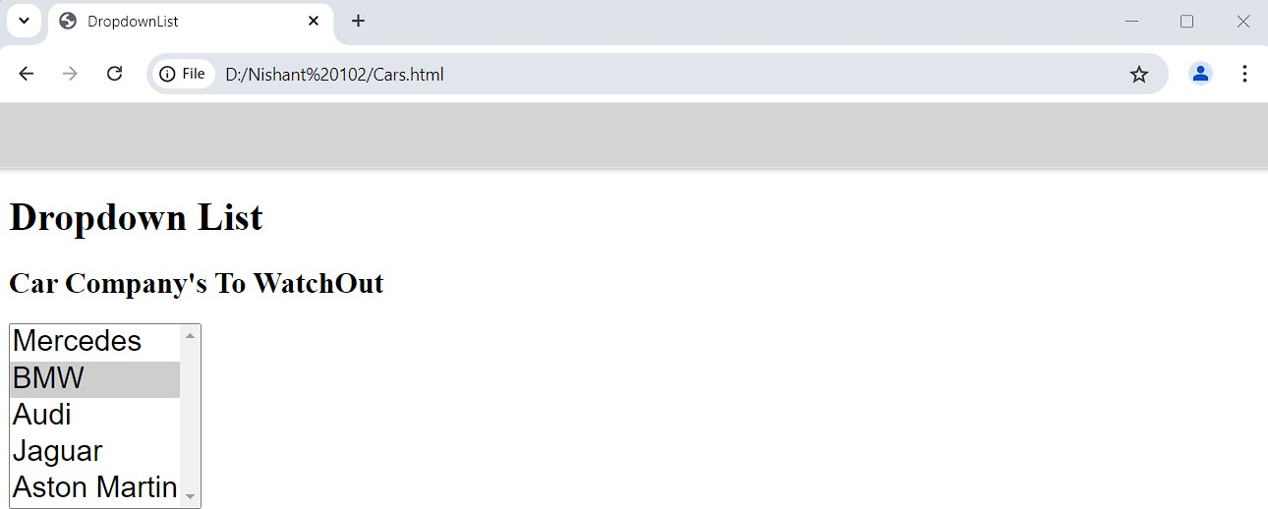

* 1. **Selecting one value using VisibleText**

package Prac4;

import org.openqa.selenium.By;

import org.openqa.selenium.WebDriver;

import org.openqa.selenium.chrome.ChromeDriver; import org.openqa.selenium.support.ui.Select; public class prac42 {

public static void main(String[] args) throws Exception { System.*setProperty*("webdriver.chrome.driver","C:\\Selenium\\ChromeDriver\\chromedriver-

win64\\chromedriver.exe");

WebDriver wd = new ChromeDriver(); wd.get("file://D:/disha%20102/Cars.html"); Thread.*sleep*(2000);

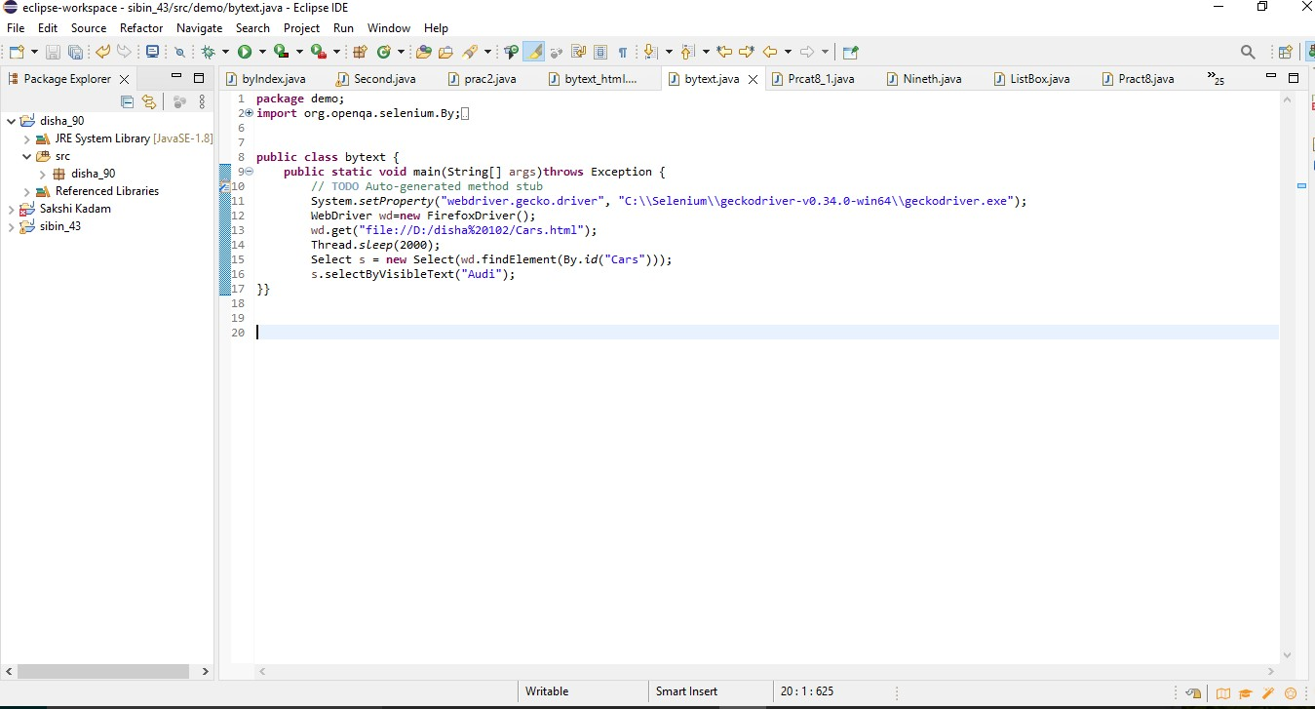Select s = new Select(wd.findElement(By.*id*("Cars"))); s.selectByVisibleText("Audi");}}

**Output:**

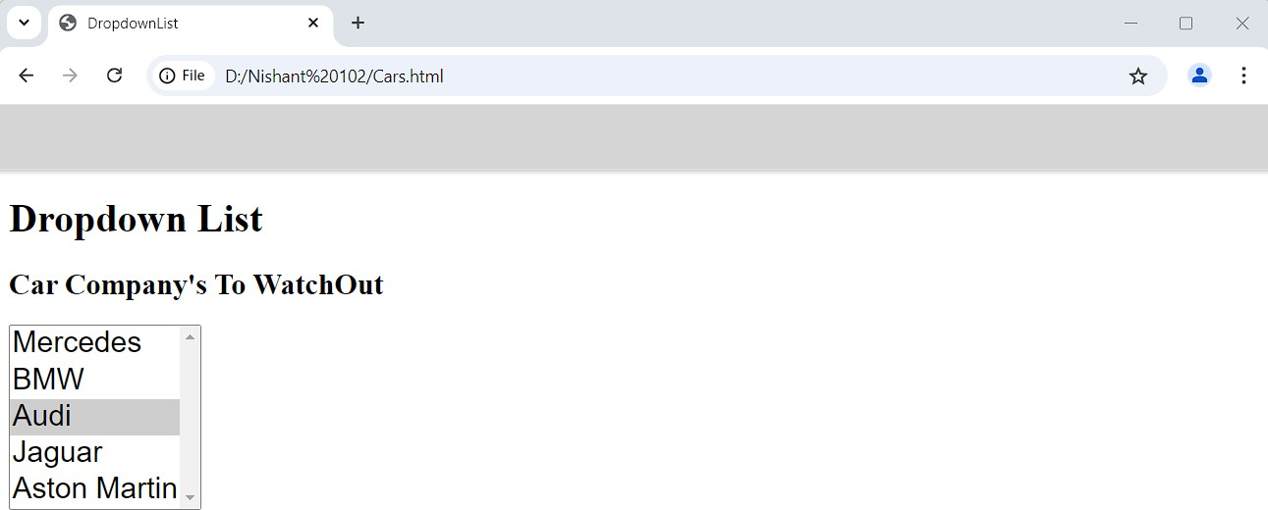

* 1. **Selecting one value usingValue**

package Prac4;

import org.openqa.selenium.By;

import org.openqa.selenium.WebDriver;

import org.openqa.selenium.chrome.ChromeDriver; import org.openqa.selenium.support.ui.Select; public class prac43 {

public static void main(String[] args) throws Exception { System.*setProperty*("webdriver.chrome.driver",

"C:\\Selenium\\ChromeDriver\\chromedriver-win64\\chromedriver.exe"); WebDriver wd = new ChromeDriver();

wd.get("file:///D:/disha%20102/Cars.html"); Thread.*sleep*(2000);

Select s = new Select(wd.findElement(By.*id*("Cars"))); s.selectByValue("5");}}

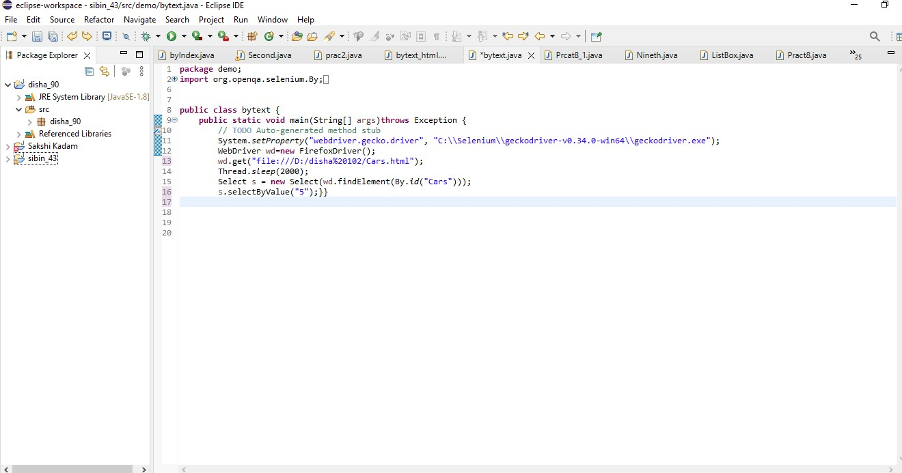

**Output:**

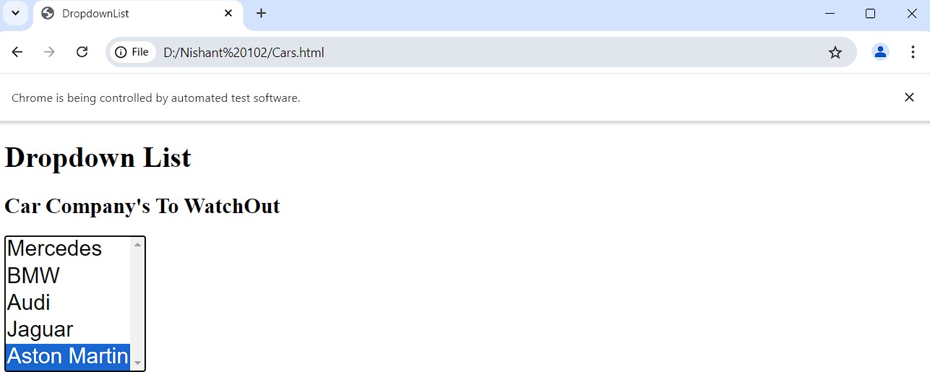

* 1. **Selecting MultipleValue**

**Multiplevalue.java**

package Prac4;

import org.openqa.selenium.By;

import org.openqa.selenium.WebDriver;

import org.openqa.selenium.chrome.ChromeDriver; import org.openqa.selenium.support.ui.Select; public class prac44 {

public static void main(String[] args) throws Exception { System.*setProperty*("webdriver.chrome.driver","C:\\Selenium\\ChromeDriver\\chromedr iver-win64\\chromedriver.exe");

WebDriver wd = new ChromeDriver(); wd.get("file:///D:/disha%20102/Cars.html"); Thread.*sleep*(2000);

Select s = new Select(wd.findElement(By.*id*("Cars"))); s.selectByIndex(1);

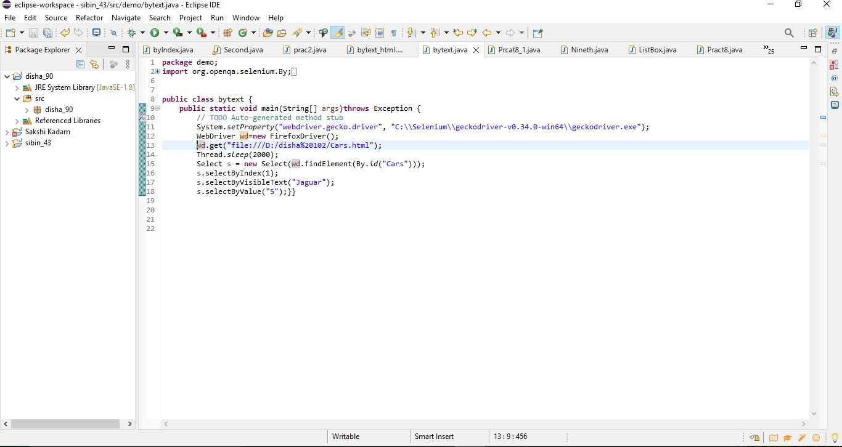s.selectByVisibleText("Jaguar"); s.selectByValue("5");}}

**Output**

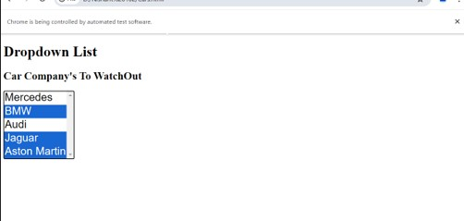

**Practical No 10**

## AIM:- To Demonstrate

## Radio Button

## CheckBox

## Radio Button

## Code:-

package prac_5;

import org.openqa.selenium.By;

import org.openqa.selenium.WebDriver;

import org.openqa.selenium.WebElement;

import org.openqa.selenium.firefox.FirefoxDriver;

public class DemoRadio

{public static void main(String[] args)

{

System.setProperty("webdriver.chrome.driver", "C:\\ Selenium webdriver\\geckodriver\\geckodriver.exe");

WebDriver wd = new FirefoxDriver();

wd.get("file:///C:/Users/lab2/Desktop/Radio.html");

wd.findElement(By.xpath("//input[@value='HTML']")).click();

}

}

## Radio.html

## <html>

<head>

<body>

<form>

<label for="fname">First Name :</label><br>

<input type="text" id="fname" name="fname"><br>

<label for="=lname">Last Name :</label><br>

<input type="text" id="lname" name="lname">

<br>

<label for="fav_language">Favorite Language</label><br>

<input type="radio" id="html" name="fav_language" value="HTML">

<label for="html">HTML</label><br>

<input type="radio" id="css" name="fav_language" value="CSS">

<label for="css">CSS</label><br>

<input type="radio" id="javascript" name="fav_language" value="JavaScript">

<label for="javascript">JavaScript</label>

</form>

</body>

</html>

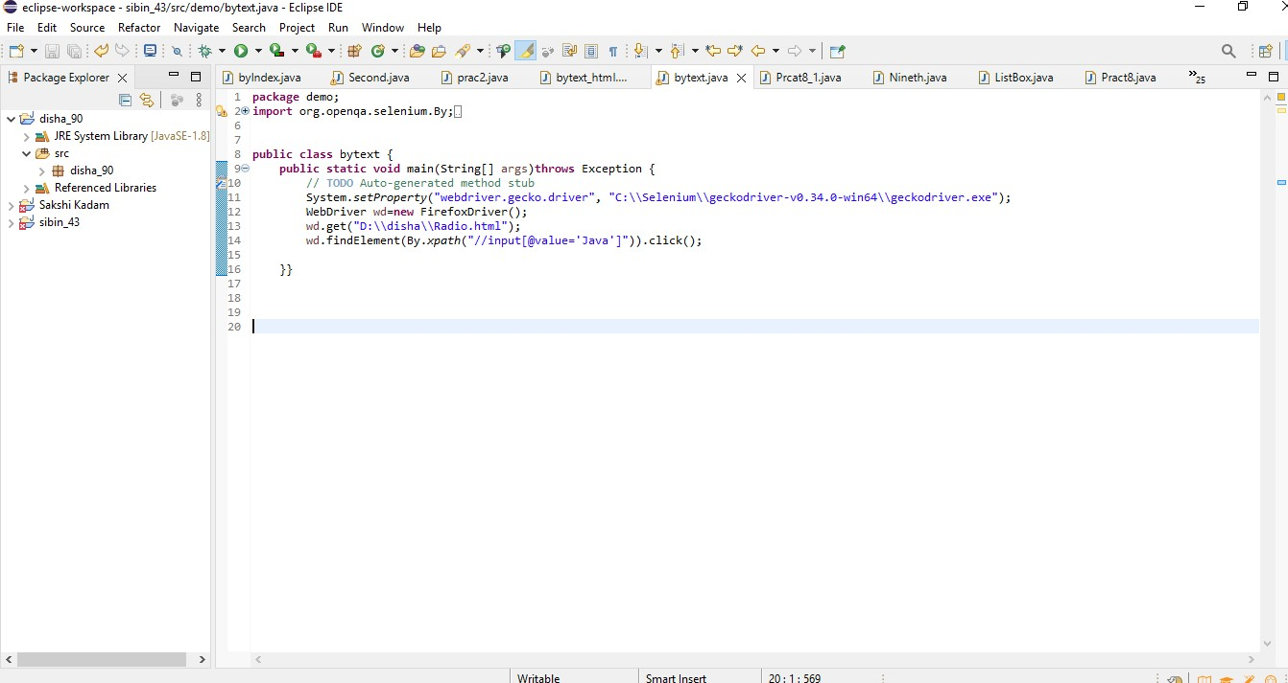

## Output:

**Checkbox Code:**

package Prac5;

import org.openqa.selenium.By;

import org.openqa.selenium.WebDriver;

import org.openqa.selenium.chrome.ChromeDriver; public class prac5a {

public static void main(String[] args) throws Exception { System.*setProperty*("webdriver.chrome.driver",

"C:\\Selenium\\ChromeDriver\\chromedriver- win64\\chromedriver.exe");

WebDriver wd = new ChromeDriver(); wd.get("D:\\disha\\checkbox.html"); wd.findElement(By.*xpath*("//input[@value='HTML']")).click();

}

}

## Checkbox.html

<!DOCTYPE html>

<html><head>

<title>Checkbox Example</title>

</head><body>

<h2>Checkbox Example</h2>

<form id="checkboxForm">

<label><input type="checkbox" id="checkbox1" value="option1">C</label><br>

<label><input type="checkbox" id="checkbox2" value="option1">C++</label><br>

<label><input type="checkbox" id="checkbox3" value="option1">Java</label><br>

<button type="button" onClick="submitForm()">Submit</button>

</form><script> function submitForm(){

document.getElementById("checkboxForm").submit();}

</script></body></html>

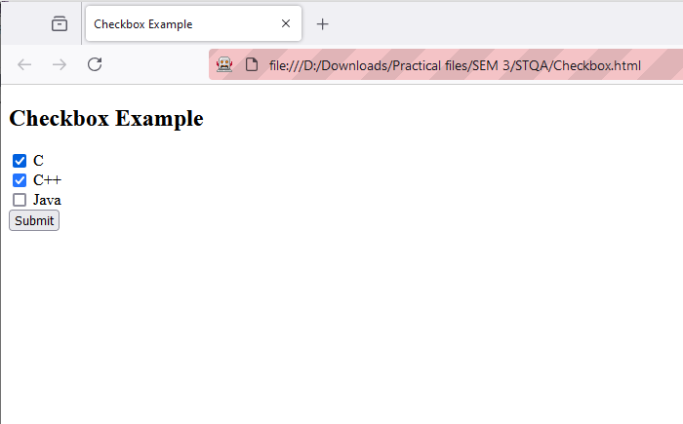**Output:**

# Practical No 11

Aim:- Demonstrate action classes in Selenium

# Code:-

**package** prac_11;

**import** java.util.List;

**import** org.openqa.selenium.By;

**import** org.openqa.selenium.WebDriver;

**import** org.openqa.selenium.WebElement;

**import** org.openqa.selenium.firefox.FirefoxDriver;

**import** org.openqa.selenium.interactions.Actions;

**public** **class** actionclasses {

**public** **static** **void** main(String[] args) **throws** InterruptedException

{

System.*setProperty*("webdriver.chrome.driver", "C:\\ Selenium webdriver\\geckodriver\\geckodriver.exe");

WebDriver wd=**new** FirefoxDriver();

wd.get("https://www.saucedemo.com/v1/");

Thread.*sleep*(3000);

wd.findElement(By.*name*("user-name")).sendKeys("standard_user");

wd.findElement(By.*name*("password")).sendKeys("secret_sauce");

wd.findElement(By.*id*("login-button")).click();

Thread.*sleep*(3000);

wd.findElement(By.*className*("bm-burger-button")).click();

Actions act = **new** Actions(wd);

Thread.*sleep*(3000);

List<WebElement> menu = wd.findElements(By.*className*("bm-item-list"));

**for**(**int** i=0; i<=menu.size()-1; i++)

{

System.***out***.println(menu.get(i).getText());

act.moveToElement(menu.get(i)).perform();

}

}

}

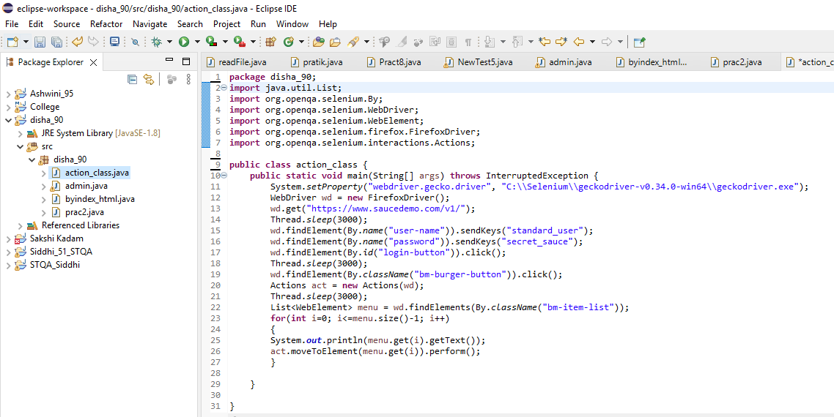

Output:-

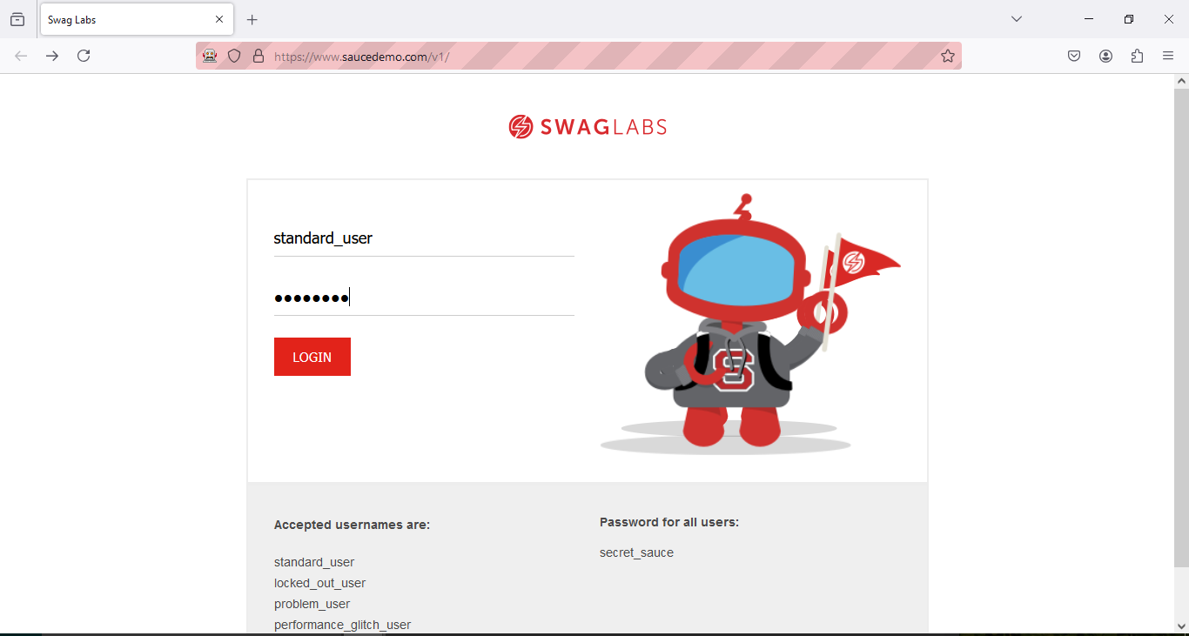

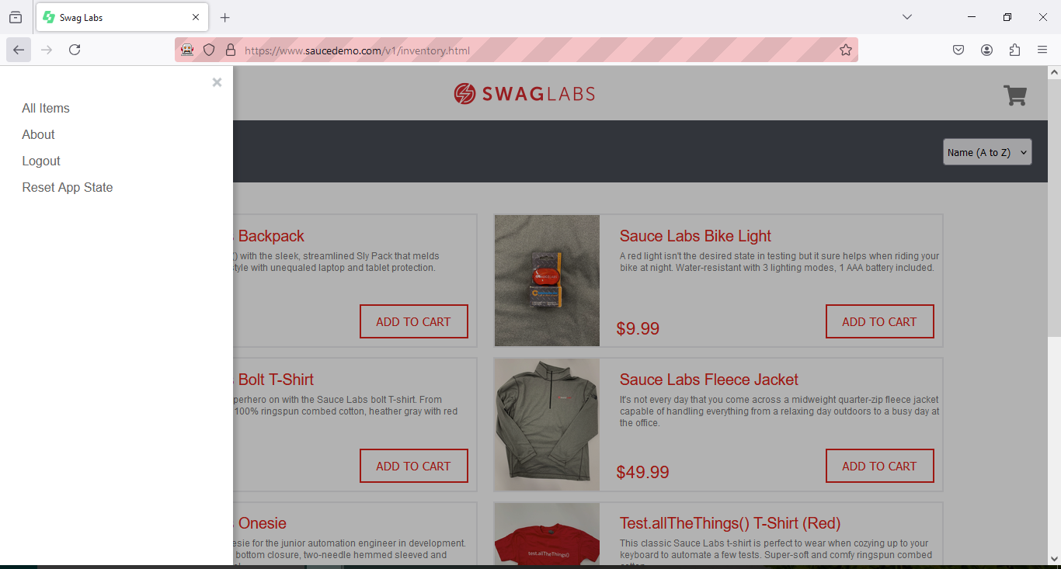

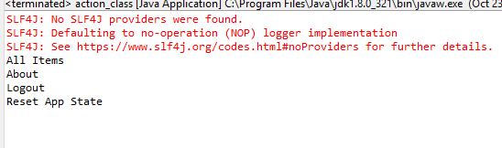

# Practical No 12

**Aim: Installation of TestNg, running TestNg & TestNg annotations.**

**Installation:**

Click on Help > Eclipse Marketplace

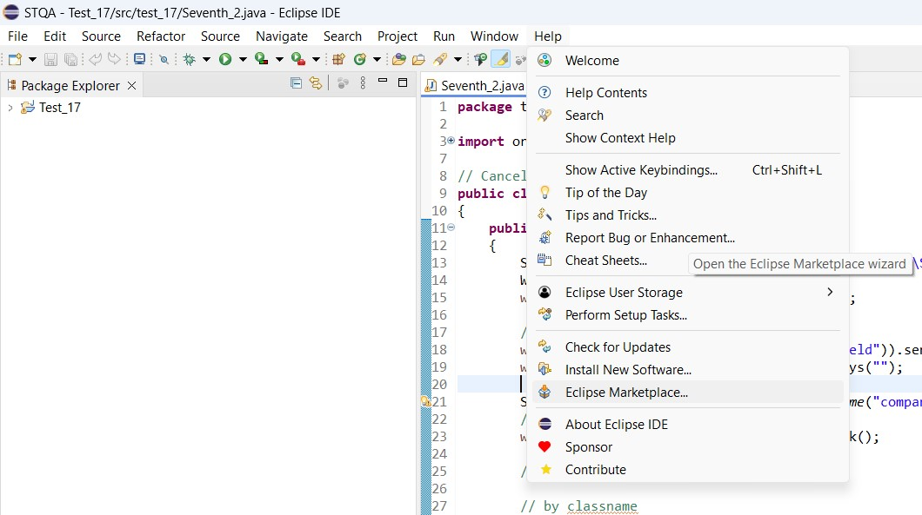

Then Type testNg and press Go

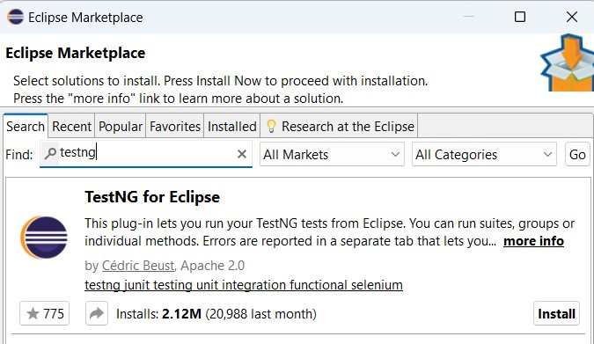

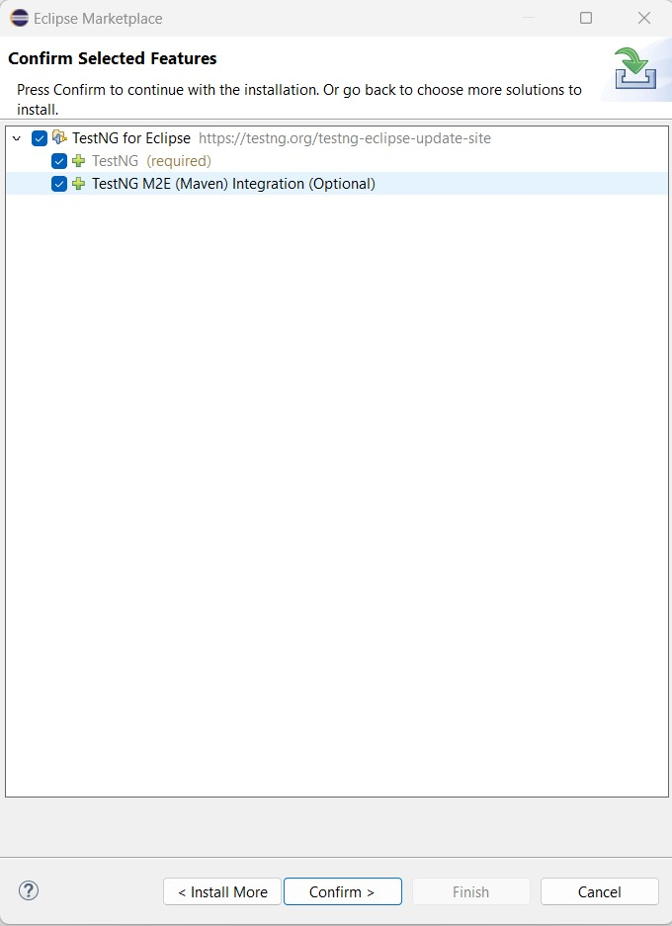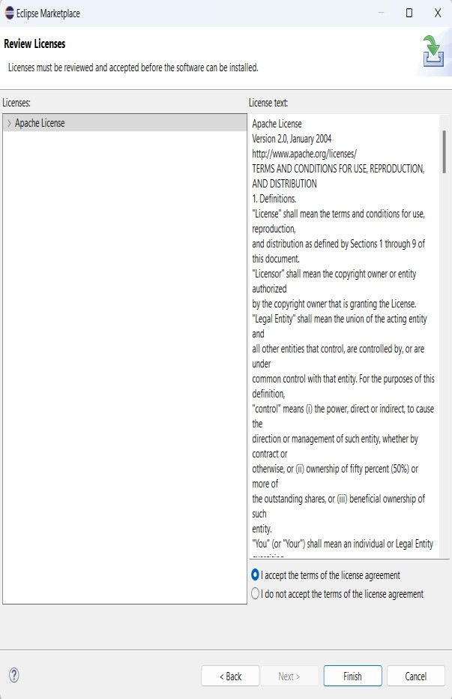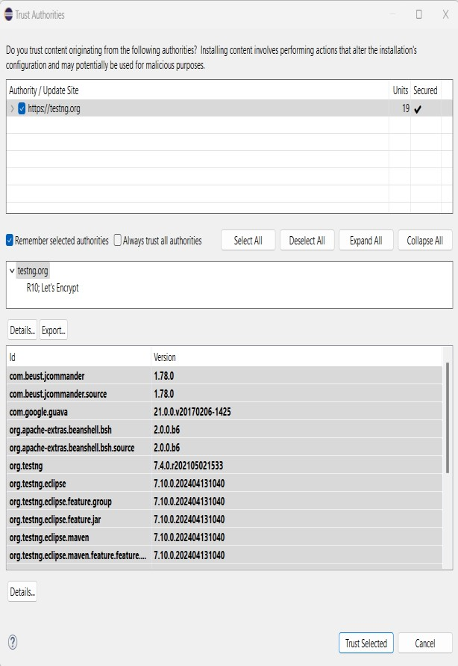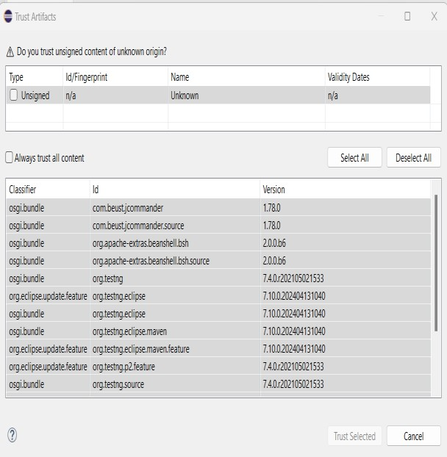

Right-Click on Project an click on Build Path then click on “Configure Build Path”

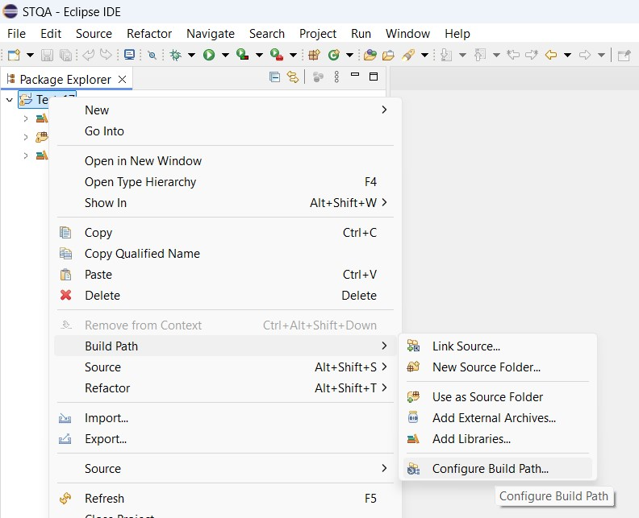

Click on Add Library

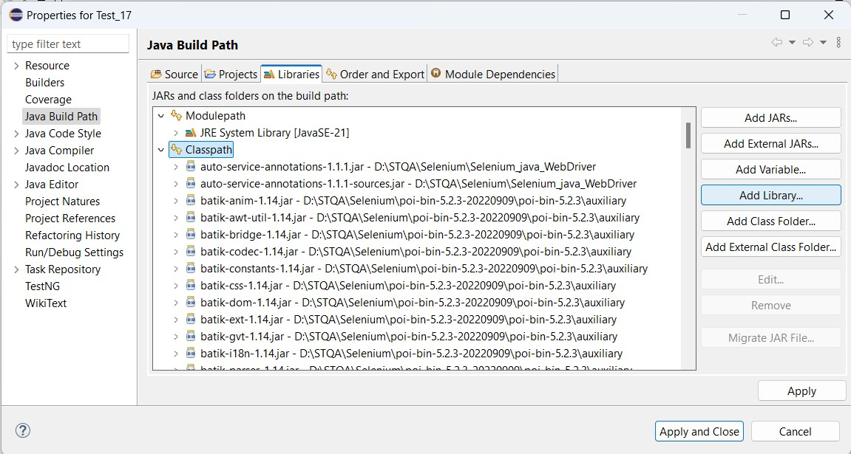

Click on TestNg then Click on Next

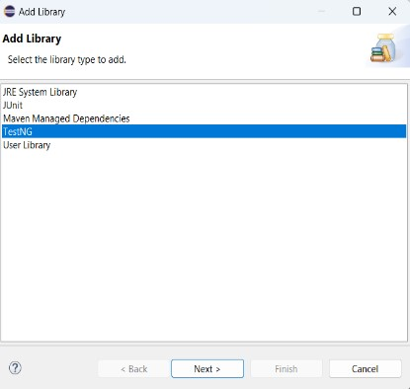

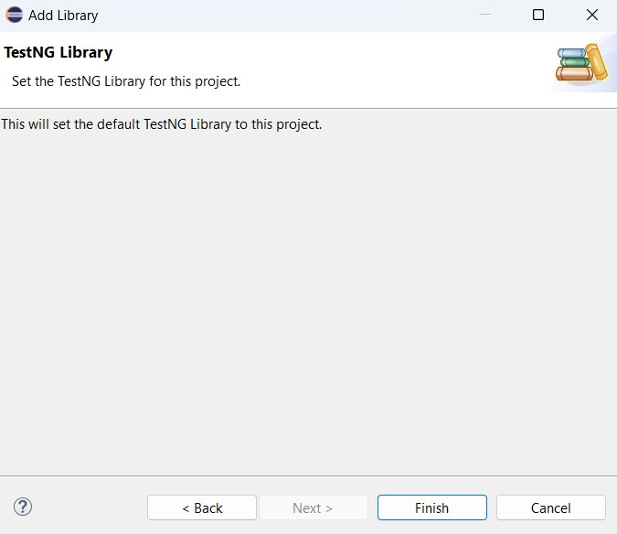

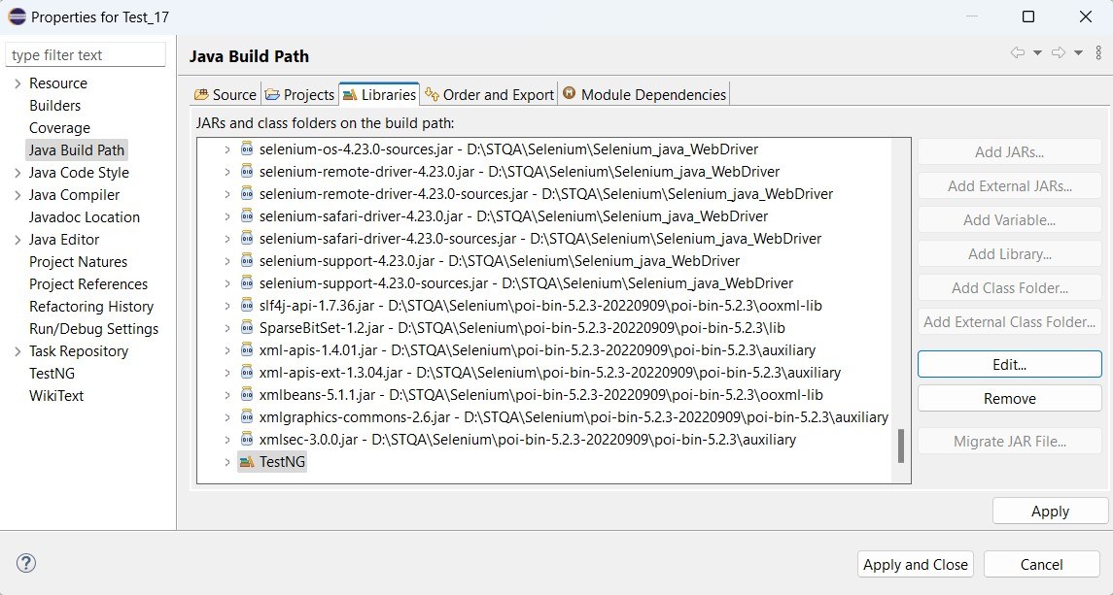

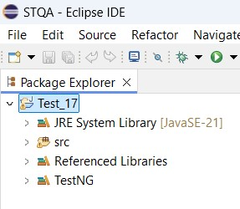

1. **DemoDataProvider**

**CODE:**

**package** testNG;

**import** org.testng.annotations.DataProvider;

**import** org.testng.annotations.Test;

**public** **class** prcat12

{

@Test(dataProvider = "dp")

**public** **void** f(Integer n, String s)

{

System.***out***.println(n + " " + s);

}

@DataProvider

**public** Object[][] dp()

{

**return** **new** Object[][]

{

**new** Object[] { 1, "A" },

**new** Object[] { 2, "B" },

**new** Object[] { 3, "C" },

**new** Object[] { 4, "DishaMane" },

};

}

}

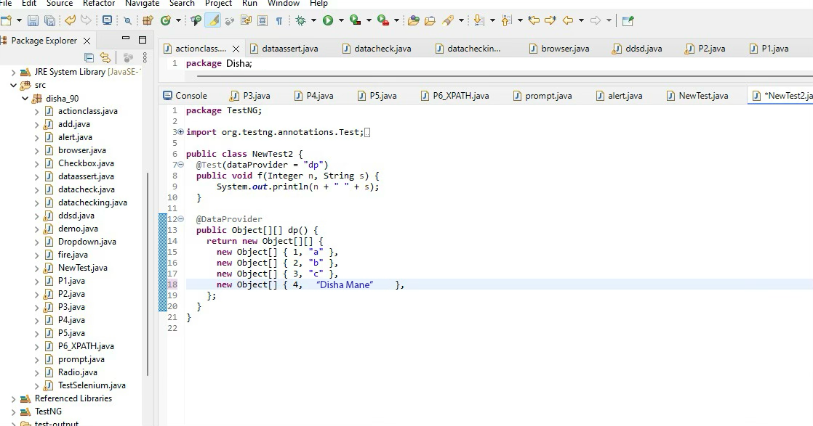

Output:-

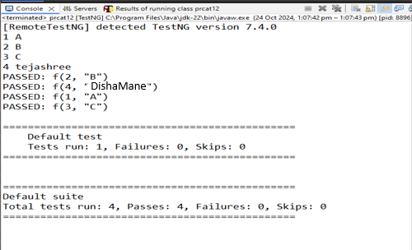

**B) DemoAnnotation**

**CODE**:

**package** testNG;

**import** org.testng.annotations.Test;

**import** org.testng.annotations.BeforeMethod;

**import** org.testng.annotations.AfterMethod;

**import** org.testng.annotations.BeforeClass;

**import** org.testng.annotations.AfterClass;

**import** org.testng.annotations.BeforeTest;

**import** org.testng.annotations.AfterTest;

**import** org.testng.annotations.BeforeSuite;

**import** org.testng.annotations.AfterSuite;

**public** **class** pract12B {

@Test

**public** **void** f() {System.***out***.println("Roll no: 90");

}

@BeforeMethod

**public** **void** beforeMethod() {

System.***out***.println("Before Method");

}

@AfterMethod

**public** **void** afterMethod() {

System.***out***.println("After Method");

}

@BeforeClass

**public** **void** beforeClass() {

System.***out***.println("Before Class");

}

@AfterClass

**public** **void** afterClass() {

System.***out***.println("After Class");

}

@BeforeTest

**public** **void** beforeTest() {

System.***out***.println("Before Test");

}

@AfterTest

**public** **void** afterTest() {

System.***out***.println("After Test");

}

@BeforeSuite

**public** **void** beforeSuite() {

System.***out***.println("Before Suite");

}

@AfterSuite

**public** **void** afterSuite() {

System.***out***.println("After Suite");

}

}

**Output:**

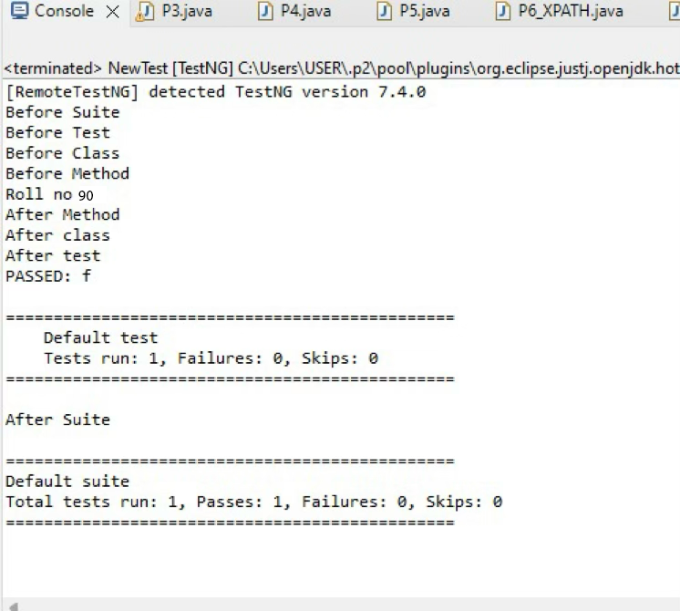

**C) DataOHM**

**CODE:**

**package** testNG;

**import** java.util.concurrent.TimeUnit;

**import** org.openqa.selenium.By;

**import** org.openqa.selenium.WebDriver;

**import** org.openqa.selenium.firefox.FirefoxDriver;

**import** org.testng.annotations.Test;

**import** org.testng.annotations.DataProvider;

@Test(dataProvider = "dp")

**public** **class** prcat12C

{

**public** **void** f(String u, String p)

{

System.*setProperty*("webdriver.chrome.driver","C:\\\\selenium web driver\\\\ChromeDriver\\\\chromedriver-win64\\\\chromedriver-win64\\\\geckodriver.exe");

WebDriver wd=**new** FirefoxDriver();

wd.get("https://opensource-demo.orangehrmlive.com/");

wd.manage().timeouts().~~implicitlyWait~~(10, TimeUnit.***SECONDS***);

wd.findElement(By.*name*("username")).sendKeys(u);//locator id

wd.findElement(By.*name*("password")).sendKeys(p);//locater name

wd.findElement(By.*className*("oxd-button")).click();

**try**

{

wd.findElement(By.*className*("oxd-userdropdown-name")).click();

wd.findElement(By.*className*("oxd-userdropdown-link")).click();

System.***out***.println("Pass");

}

**catch** (Exception e)

{

System.***out***.println("Fail");

}

}

@DataProvider

**public** Object[][] dp()

{

**return** **new** Object[][]

{

**new** Object[] { "Admin", "admin123" },

**new** Object[] { "add", "b" },

};

}

}

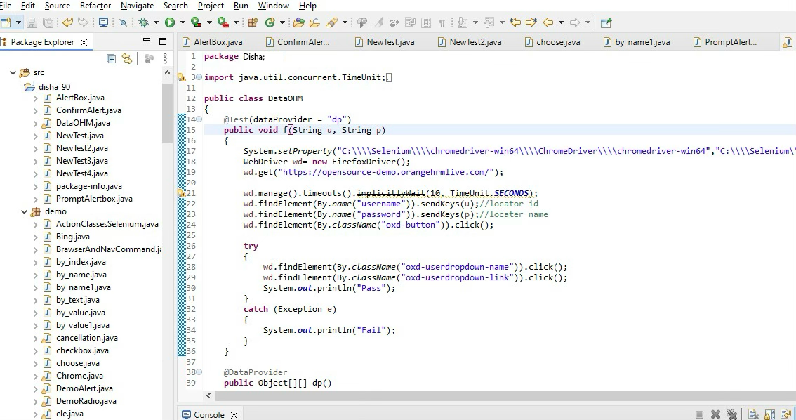

## Output:-

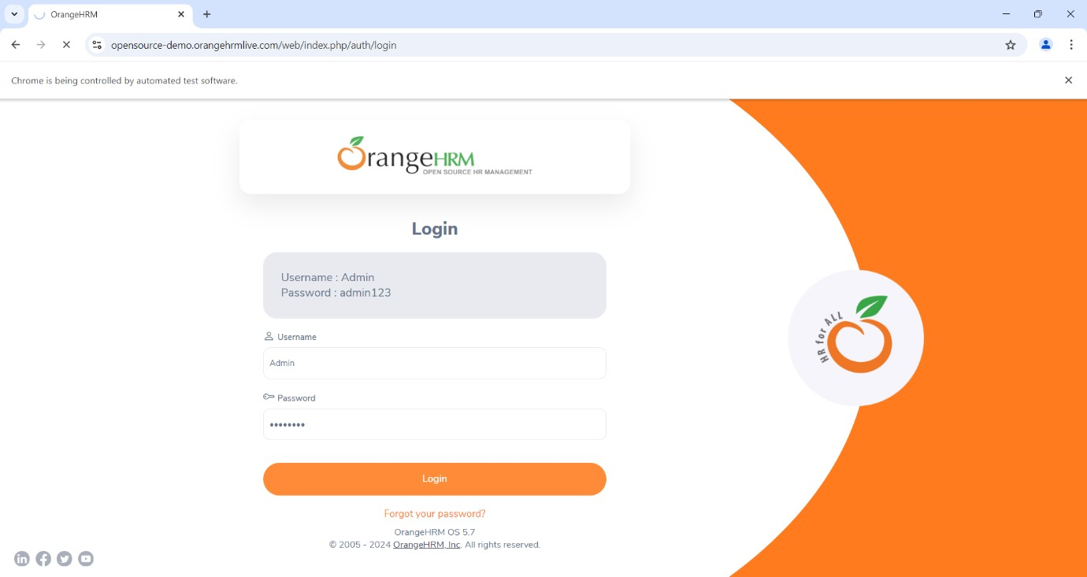

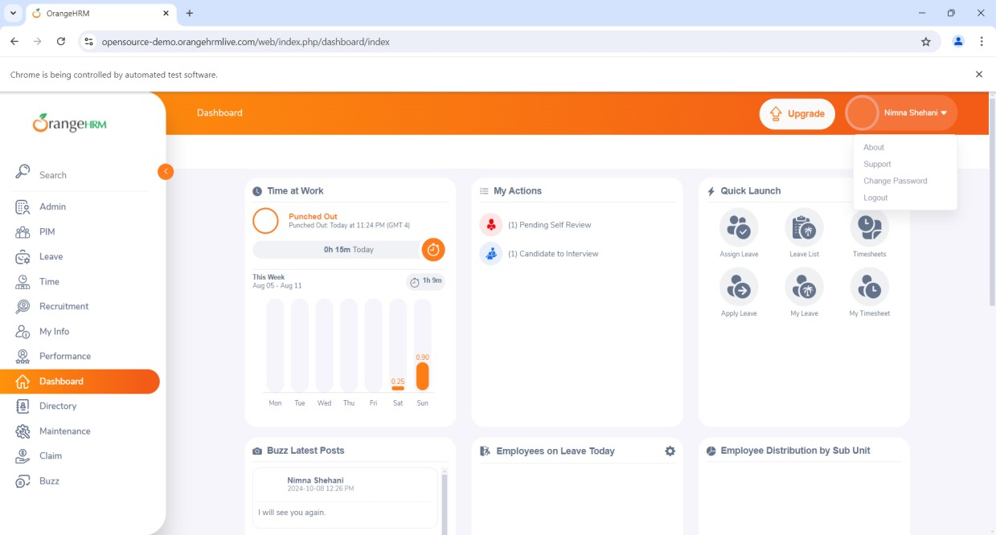

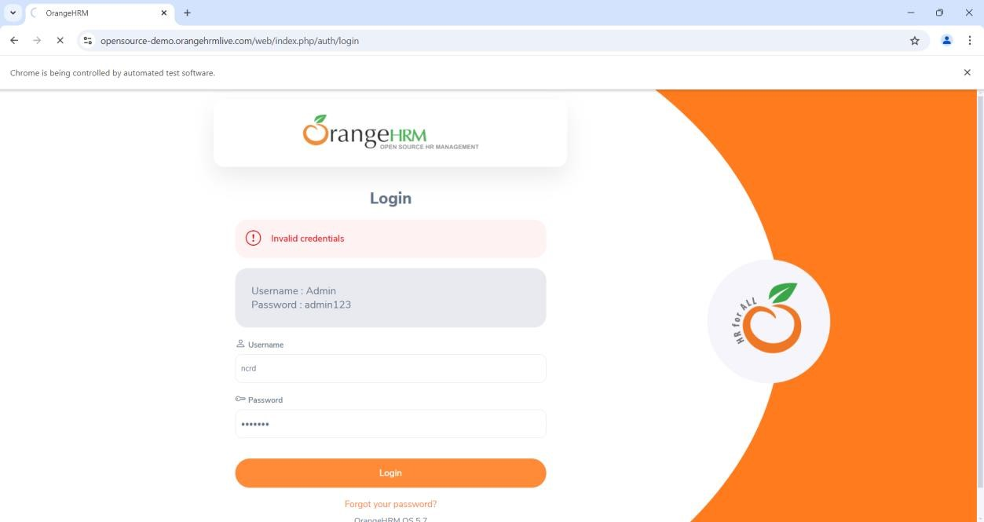

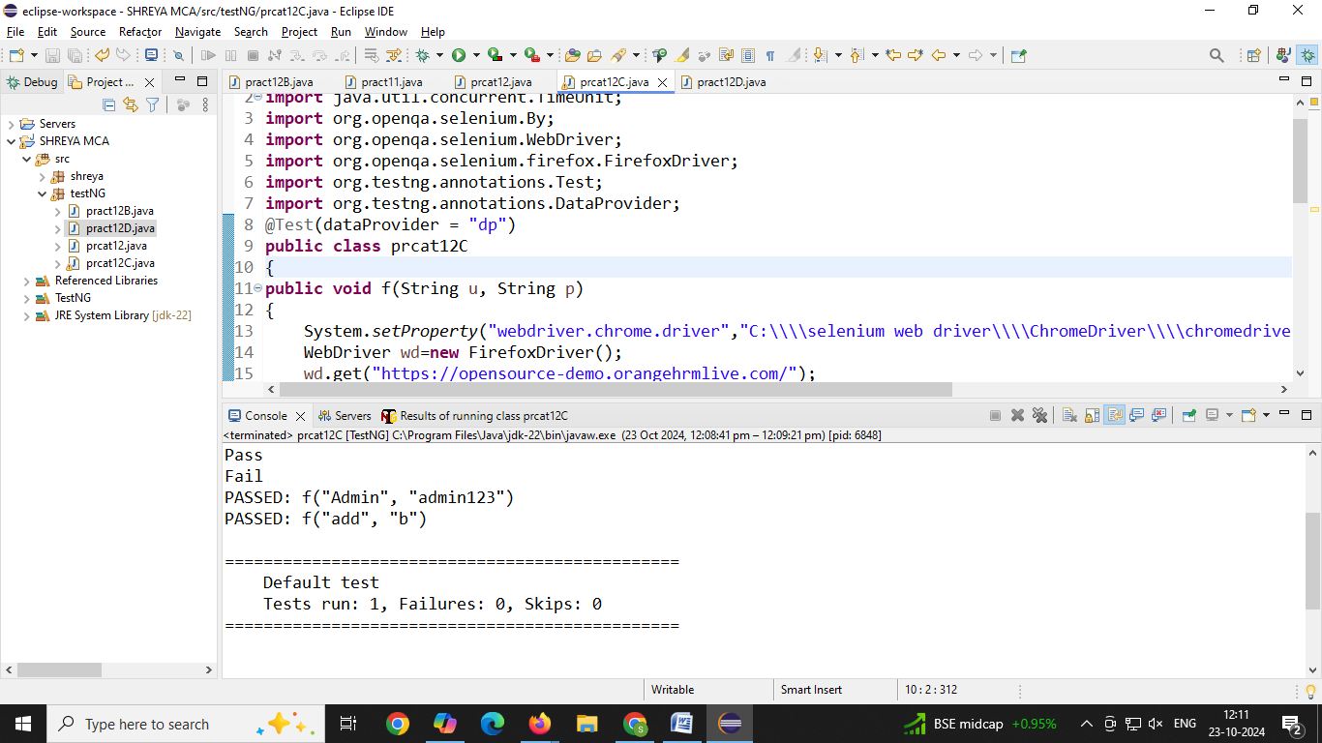

**D) DataCheck**

**CODE:**

**package** testNG;

**import** org.openqa.selenium.By;

**import** org.openqa.selenium.WebDriver;

**import** org.openqa.selenium.firefox.FirefoxDriver;

**import** org.testng.Assert;

**import** org.testng.annotations.Test;

**public** **class** pract12D

{

@Test(description="Checking status of checkbox")

**public** **void** ChekBox()

{

System.*setProperty*("webdriver.chrome.driver","C:\\\\selenium web driver\\\\ChromeDriver\\\\chromedriver-win64\\\\chromedriver-win64\\\\geckodriver.exe");

WebDriver wd=**new** FirefoxDriver();

wd.get("https://mail.rediff.com/cgi-bin/login.cgi");

**boolean** sts = wd.findElement(By.*name*("remember")).isSelected();

Assert.*assertTrue*(sts);

}

}

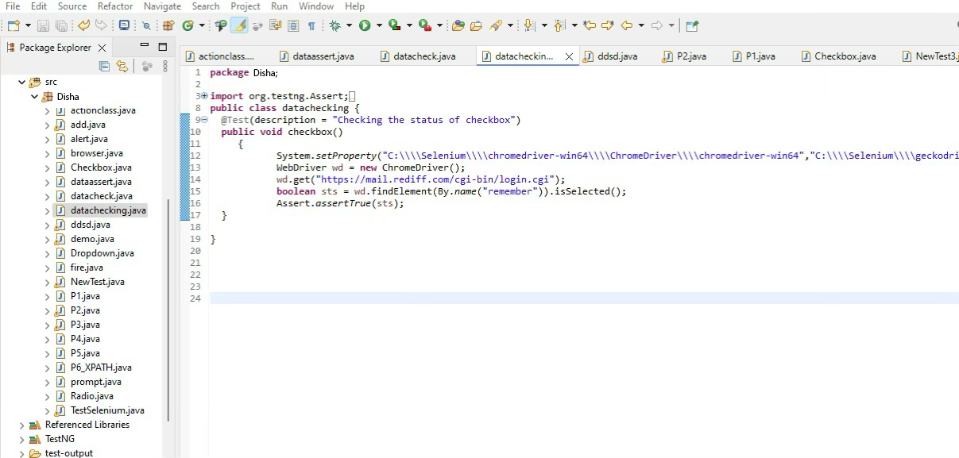

## Output:-

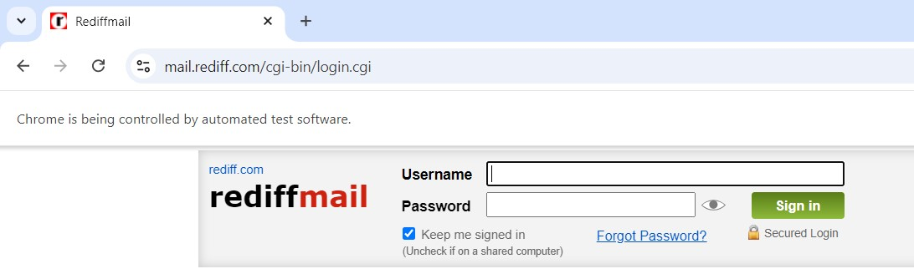

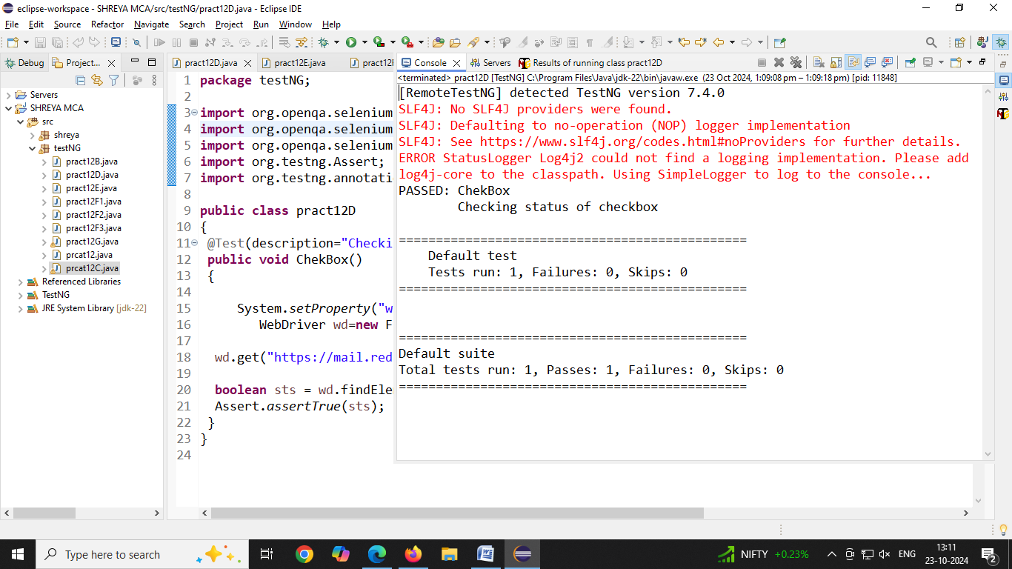

**E) DemoAssertFA**

**CODE:**

**package** testNG;

**import** org.openqa.selenium.WebDriver;

**import** org.openqa.selenium.firefox.FirefoxDriver;

**import** org.testng.Assert;

**import** org.testng.annotations.Test;

**public** **class** pract12E

{

@Test

**public** **void** frontAccounting()

{

System.*setProperty*("webdriver.chrome.driver","C:\\\\selenium web driver\\\\ChromeDriver\\\\chromedriver-win64\\\\chromedriver-win64\\\\geckodriver.exe");

WebDriver wd=**new** FirefoxDriver();

wd.get("https://demo.frontaccounting.eu/index.php");

String expectedTitle = "FrontAccounting 2.4.12 - Login";//if title is not matching execution will be fail

String actualTitle = wd.getTitle();

Assert.*assertEquals*(actualTitle, expectedTitle);

System.***out***.println("Title of Webpage =====> " + actualTitle);

}

}

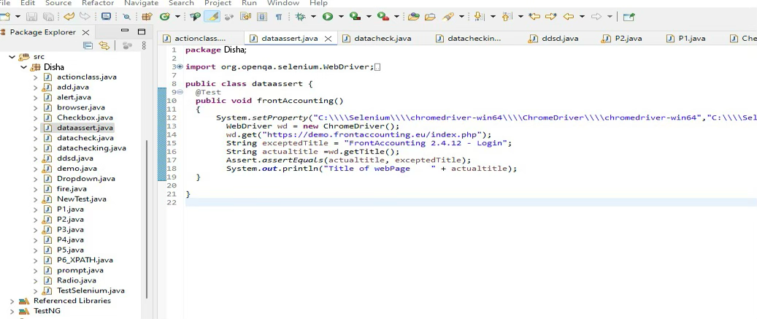

**Output:**

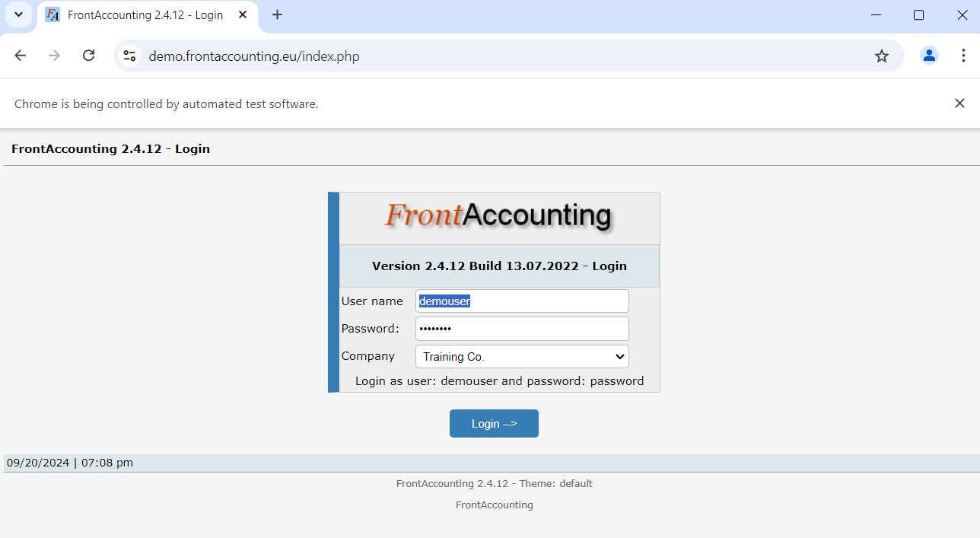

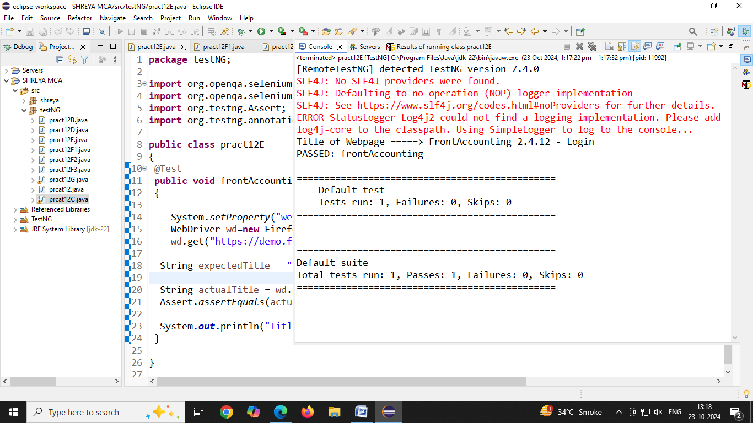 **F) DemoAlert :-**

**1) Alertbox**

**CODE**

**package** testNG;

**import** org.openqa.selenium.Alert;

**import** org.openqa.selenium.By;

**import** org.openqa.selenium.WebDriver;

**import** org.openqa.selenium.firefox.FirefoxDriver;

**public** **class** pract12F1

{

**public** **static** **void** main(String[] args) **throws** Exception

{

System.*setProperty*("webdriver.chrome.driver","C:\\\\selenium web driver\\\\ChromeDriver\\\\chromedriver-win64\\\\chromedriver-win64\\\\geckodriver.exe");

WebDriver wd=**new** FirefoxDriver();

wd.get("https://vinothqaacademy.com/alert-and-popup/");

wd.findElement(By.*name*("alertbox")).click();

Thread.*sleep*(2000);

Alert alt = wd.switchTo().alert();

System.***out***.println("Text of Alert " + alt.getText());//capture text

alt.accept();//click on OK button

}

}

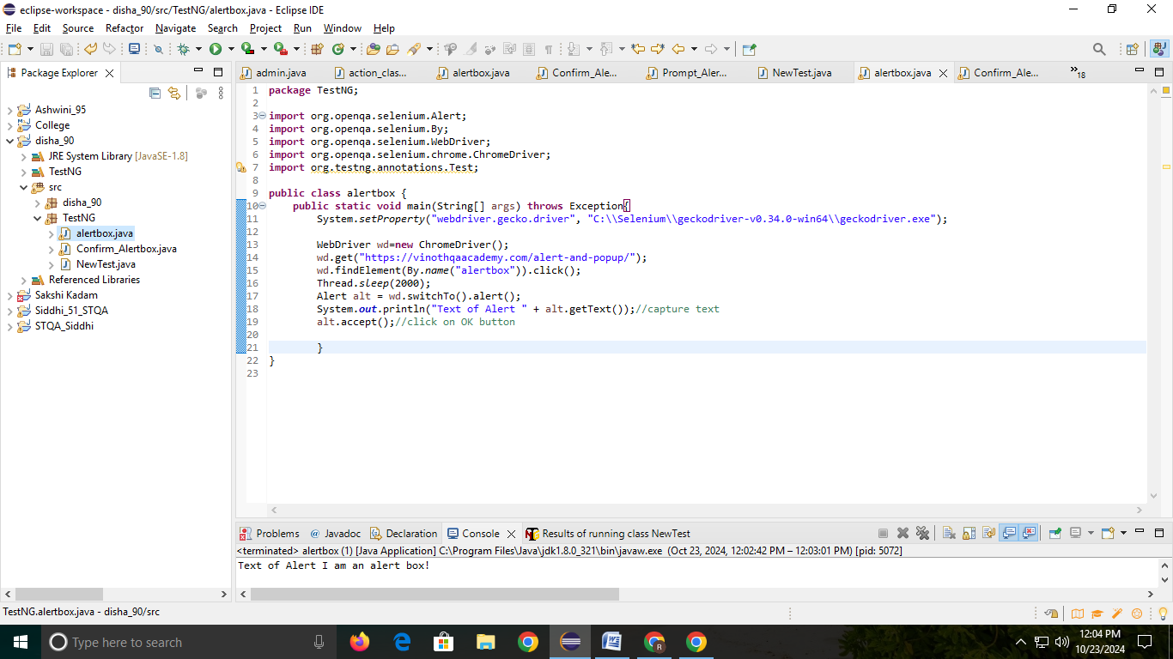

O/p:-

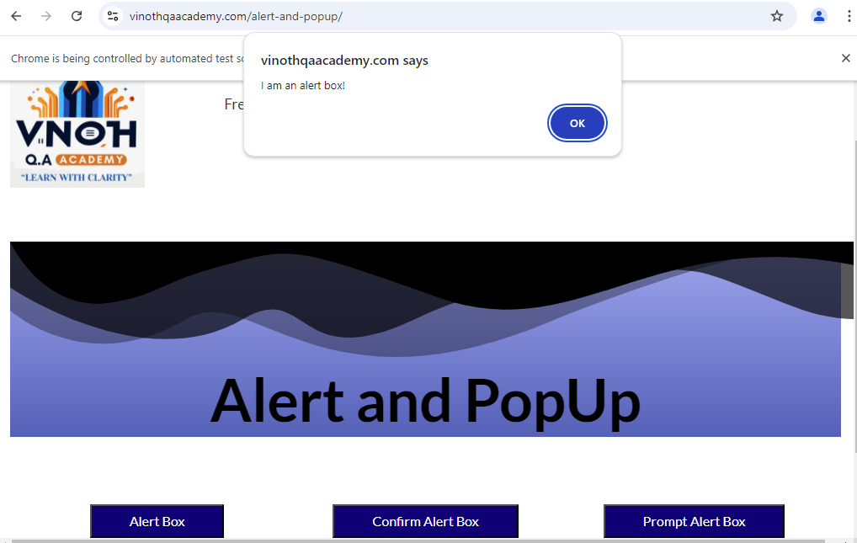

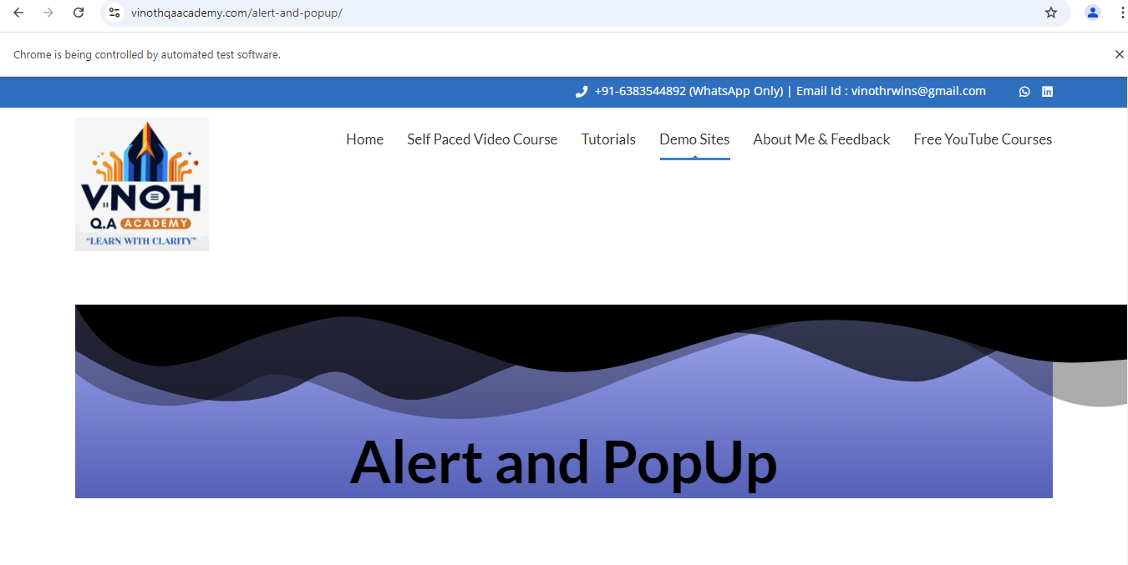

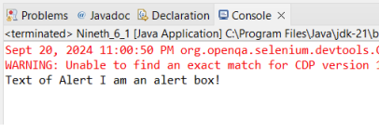

**2) Confirm Alertbox:-**

**CODE**:

**package** testNG;

**import** org.openqa.selenium.Alert;

**import** org.openqa.selenium.By;

**import** org.openqa.selenium.WebDriver;

**import** org.openqa.selenium.firefox.FirefoxDriver;

**public** **class** pract12F2

{

**public** **static** **void** main(String[] args) **throws** Exception

{

System.*setProperty*("webdriver.chrome.driver","C:\\\\selenium web driver\\\\ChromeDriver\\\\chromedriver-win64\\\\chromedriver-win64\\\\geckodriver.exe");

WebDriver wd=**new** FirefoxDriver();

wd.get("https://vinothqaacademy.com/alert-and-popup/");

wd.findElement(By.*name*("confirmalertbox")).click();

Thread.*sleep*(2000);

Alert alt = wd.switchTo().alert();

System.***out***.println("Text of Alert " + alt.getText());//capture text

alt.accept();//click on OK button

}

} 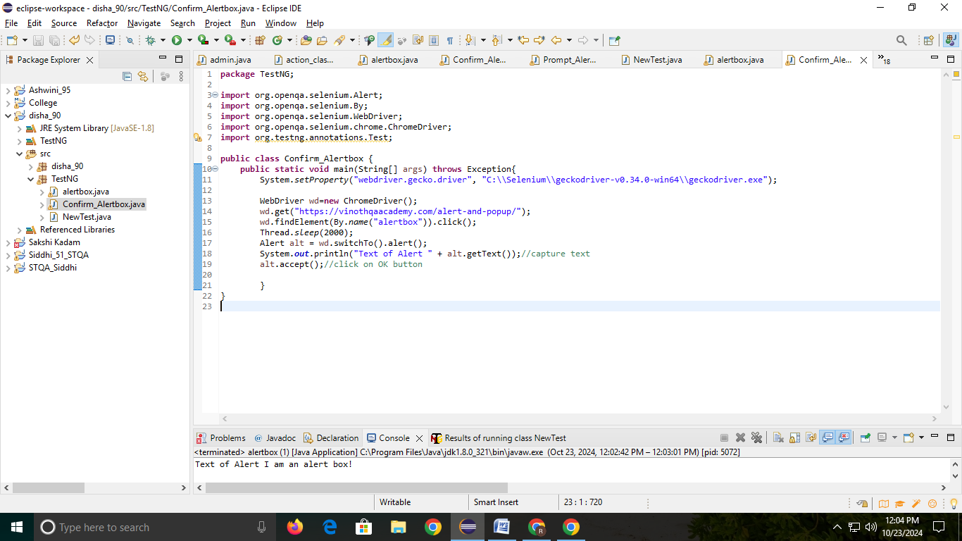

Output:-

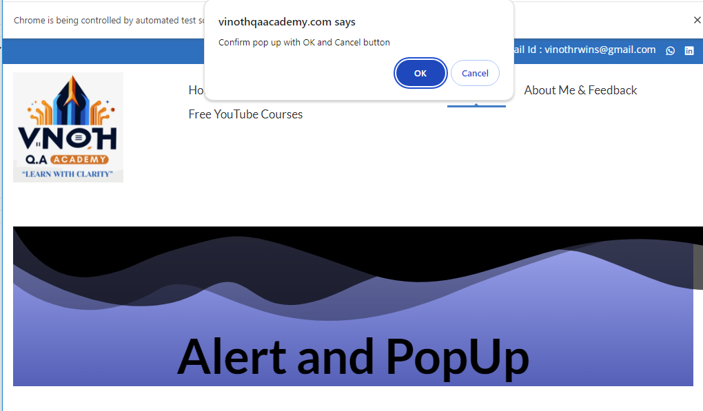

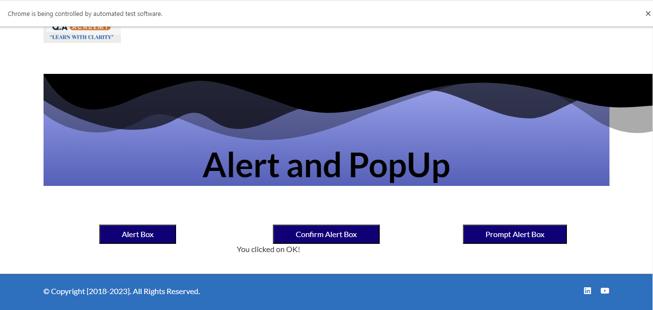

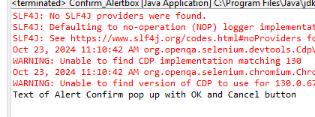

**3) Prompt Alertbox :-**

## CODE:

**package** testNG;

**import** org.openqa.selenium.Alert;

**import** org.openqa.selenium.By;

**import** org.openqa.selenium.WebDriver;

**import** org.openqa.selenium.firefox.FirefoxDriver;

**import** org.testng.annotations.BeforeClass;

**import** org.testng.annotations.Test;

**public** **class** pract12F3

{

WebDriver wd;

@BeforeClass

**public** **void** setup()

{

System.*setProperty*("webdriver.chrome.driver","C:\\\\selenium web driver\\\\ChromeDriver\\\\chromedriver-win64\\\\chromedriver-win64\\\\geckodriver.exe");

WebDriver wd=**new** FirefoxDriver();

wd.get("https://vinothqaacademy.com/alert-and-popup/");

}

@Test

**public** **void** testAlertInput() **throws** InterruptedException

{

wd.findElement(By.*name*("promptalertbox1234")).click(); // Assuming there's a prompt box

Thread.*sleep*(2000); // Wait for the alert to appear

// Handle the prompt dialog

String inputText = "Yes"; // Simulated user input

wd.switchTo().alert().sendKeys(inputText); // Send input to the alert

Alert alt = wd.switchTo().alert();

System.***out***.println("Text of Alert " + alt.getText());//capture text

alt.accept(); // Click OK

}

}

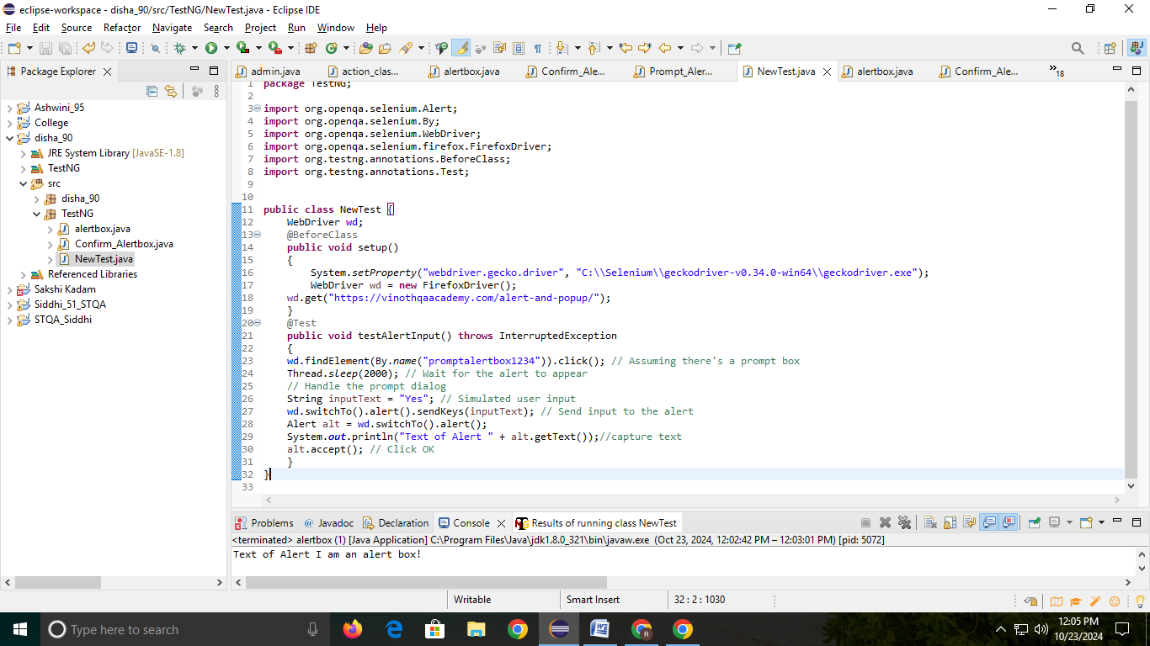

O/p:-

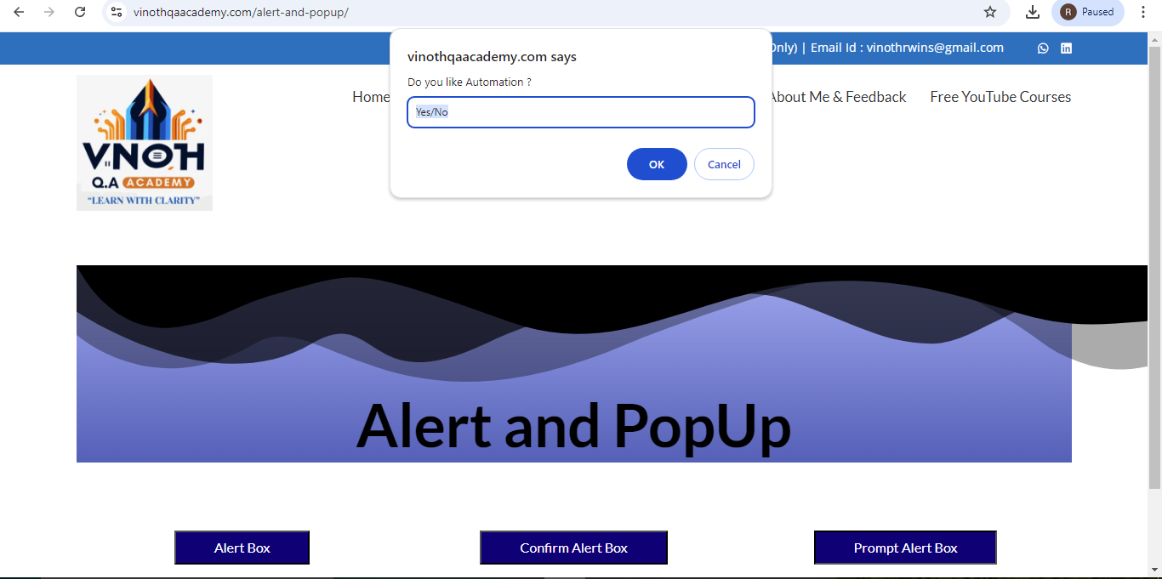

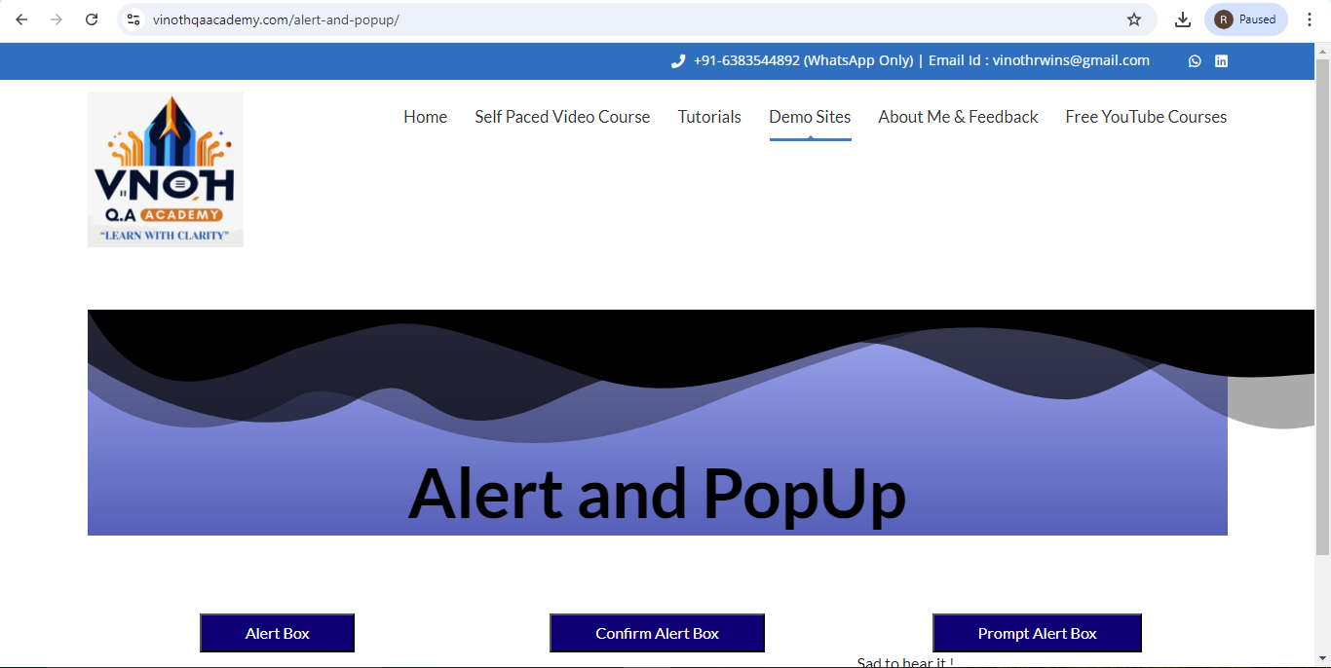

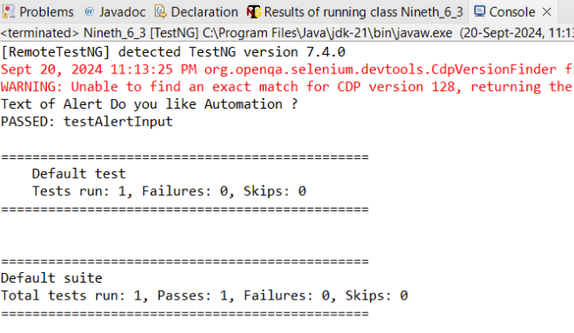

**G) DemoOHM**

**CODE:**

**package** testNG;

**import** java.util.concurrent.TimeUnit;

**import** org.openqa.selenium.By;

**import** org.openqa.selenium.WebDriver;

**import** org.openqa.selenium.firefox.FirefoxDriver;

**import** org.testng.annotations.AfterClass;

**import** org.testng.annotations.AfterSuite;

**import** org.testng.annotations.BeforeClass;

**import** org.testng.annotations.BeforeSuite;

**import** org.testng.annotations.Test;

**public** **class** pract12G

{

WebDriver wd;

@BeforeSuite

**public** **void** openBrowser()

{

System.*setProperty*("webdriver.chrome.driver","C:\\\\selenium web driver\\\\ChromeDriver\\\\chromedriver-win64\\\\chromedriver-win64\\\\geckodriver.exe");

wd = **new** FirefoxDriver();

}

@BeforeClass

**public** **void** loginOHM()

{

wd.get("https://opensource-demo.orangehrmlive.com/");

wd.manage().timeouts().~~implicitlyWait~~(10, TimeUnit.***SECONDS***);

wd.findElement(By.*name*("username")).sendKeys("admin");//locator id

wd.findElement(By.*name*("password")).sendKeys("admin123");//locater name

wd.findElement(By.*className*("oxd-button")).click();//locatorclassName

}

@Test(priority = 2)

**public** **void** myInfo()

{

wd.findElement(By.*className*("oxd-main-menu-item")).click();

}

@Test(priority = 1)

**public** **void** pim()

{

wd.findElement(By.*className*("oxd-main-menu-item")).click();

}

@AfterClass

**public** **void** logoutOHM() **throws** Exception

{

wd.findElement(By.*className*("oxd-userdropdown-name")).click();//locator partiallinkText

Thread.*sleep*(2000);

wd.findElement(By.*partialLinkText*("Logout")).click();//locatorlinkText

}

@AfterSuite

**public** **void** closeBrowser()

{

wd.quit();

}

}

**Output**

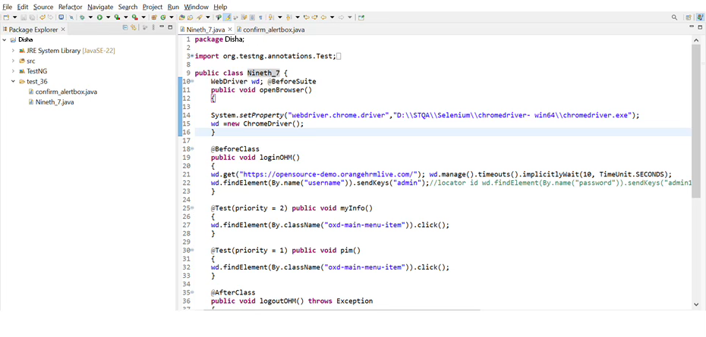



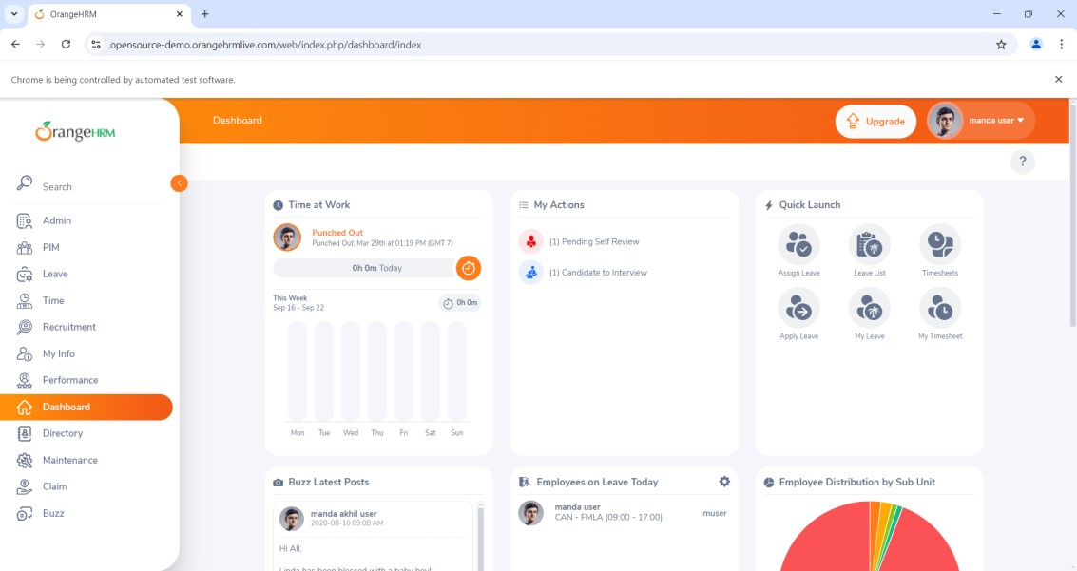

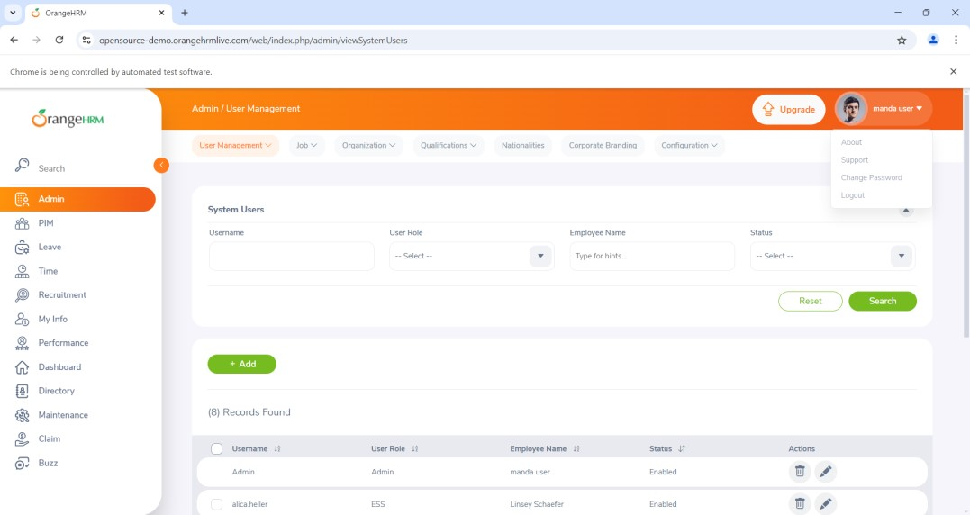

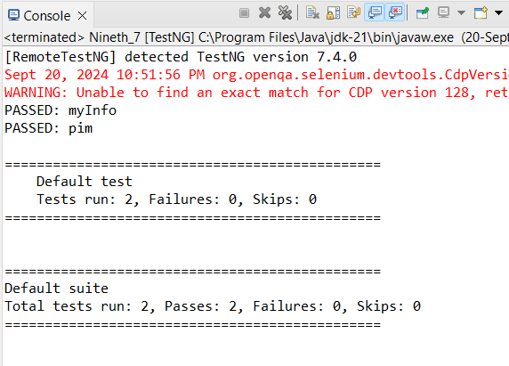

**Practical No 13**

## Aim:- Demonstrate data driven Framework

**1) File read data from Excel and perform testing using selenium.**

**Code:-**

package disha_90;

import java.io.FileInputStream; import java.io.IOException; import org.apache.poi.xssf.usermodel.XSSFCell; import org.apache.poi.xssf.usermodel.XSSFRow; import org.apache.poi.xssf.usermodel.XSSFSheet; import org.apache.poi.xssf.usermodel.XSSFWorkbook;

// Get Data From Excel public class Eighth_1

{

public static void main(String[] args) throws IOException

{

FileInputStream fis = new FileInputStream("D:\\STQA\\ExcelData.xlsx");

XSSFWorkbook wb = new XSSFWorkbook(fis);

XSSFSheet sh = wb.getSheet("Sheet1");

for (int i = 1; i <= sh.getLastRowNum(); i++)

{

XSSFRow rw = sh.getRow(i);

XSSFCell un = rw.getCell(0);

XSSFCell pw = rw.getCell(1);

XSSFCell rs = rw.getCell(2);

System.out.println("Username --->" + un + " " + "Password --->" + pw +

" " +"Result --->" + rs );

}

}

}

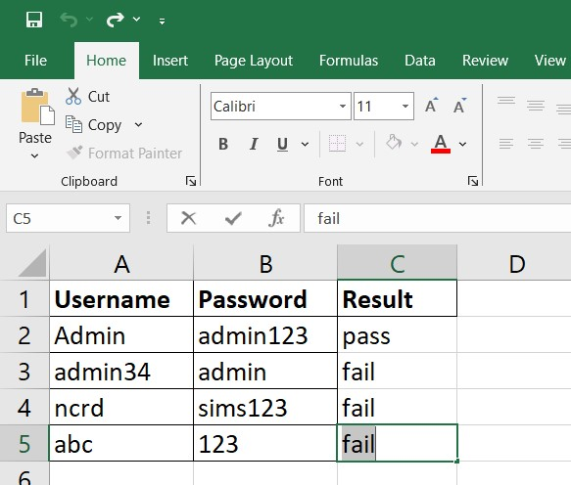

Output:-

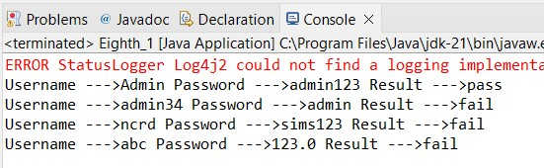

**2) Write a Program to Read data from an Excel file and login in to site.**

Code:-

Package disha_90;

import java.io.FileInputStream; import java.io.FileOutputStream; import java.io.IOException; import java.util.concurrent.TimeUnit;

import org.apache.poi.xssf.usermodel.XSSFCell; import org.apache.poi.xssf.usermodel.XSSFRow; import org.apache.poi.xssf.usermodel.XSSFSheet; import org.apache.poi.xssf.usermodel.XSSFWorkbook; import org.openqa.selenium.By; import org.openqa.selenium.WebDriver;

import org.openqa.selenium.chrome.ChromeDriver;

public class Eighth_3

{

public static void main(String[] args) throws IOException

{ System.setProperty("webdriver.chrome.driver","D:\\STQA\\Selenium\\chromedriverwin64\\chromedriver.exe");

WebDriver wd = new ChromeDriver();

wd.get("https://opensource-demo.orangehrmlive.com/");

FileInputStream fis = new FileInputStream("D:\\STQA\\ExcelData_1.xlsx");

XSSFWorkbook wb = new XSSFWorkbook(fis);

XSSFSheet sh = wb.getSheet("WriteData");

for(int i=1;i<=sh.getLastRowNum();i++)

{

XSSFRow rw = sh.getRow(i);

XSSFCell un = rw.getCell(0);

XSSFCell pw = rw.getCell(1);

XSSFCell res = rw.createCell(2);

System.out.println("username --> "+ un + " " + "Password --> "+ pw);

wd.manage().timeouts().implicitlyWait(10,TimeUnit.SECONDS); wd.findElement(By.name("username")).sendKeys(un.toString()); wd.findElement(By.name("password")).sendKeys(pw.toString()); wd.findElement(By.className("oxd-button")).click();

try {

wd.findElement(By.className("oxd-userdropdownname")).click();

wd.findElement(By.partialLinkText("Logout")).click();

System.out.println("Login Pass");

res.setCellValue("Valid");

}

catch (Exception e) {

System.out.println("Login Fail");

res.setCellValue("Invalid");

}

}

FileOutputStream fos = new

FileOutputStream("D:\\STQA\\ExcelData_1.xlsx");

wb.write(fos);

fis.close();

}

}

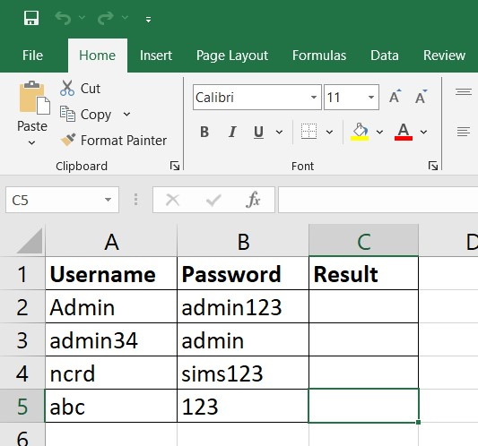

Output:-







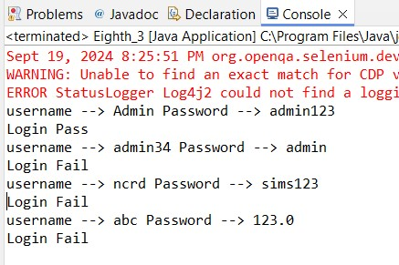

# Practical No 14

**Aim:** Validation testing using chrome and bing

**Prac6.java Code:**

package Prac6;

import org.openqa.selenium.By; import org.openqa.selenium.Keys;

import org.openqa.selenium.WebDriver;

import org.openqa.selenium.chrome.ChromeDriver public class prac6 {

public static void main(String[] args) throws Exception {

// TODO Auto-generated method stub System.setProperty("webDriver.chrome.driver",

"C:\\Selenium\\ChromeDriver\\chromedriver-win64\\chromedriver.exe"); WebDriver wd = new ChromeDriver();

wd.get("https:/[/www.google.com/](http://www.google.com/)"); Thread.sleep(2000);

wd.findElement(By.className("gLFyf")).sendKeys("Cars"); wd.findElement(By.className("gLFyf")).sendKeys(Keys.ENTER);

}

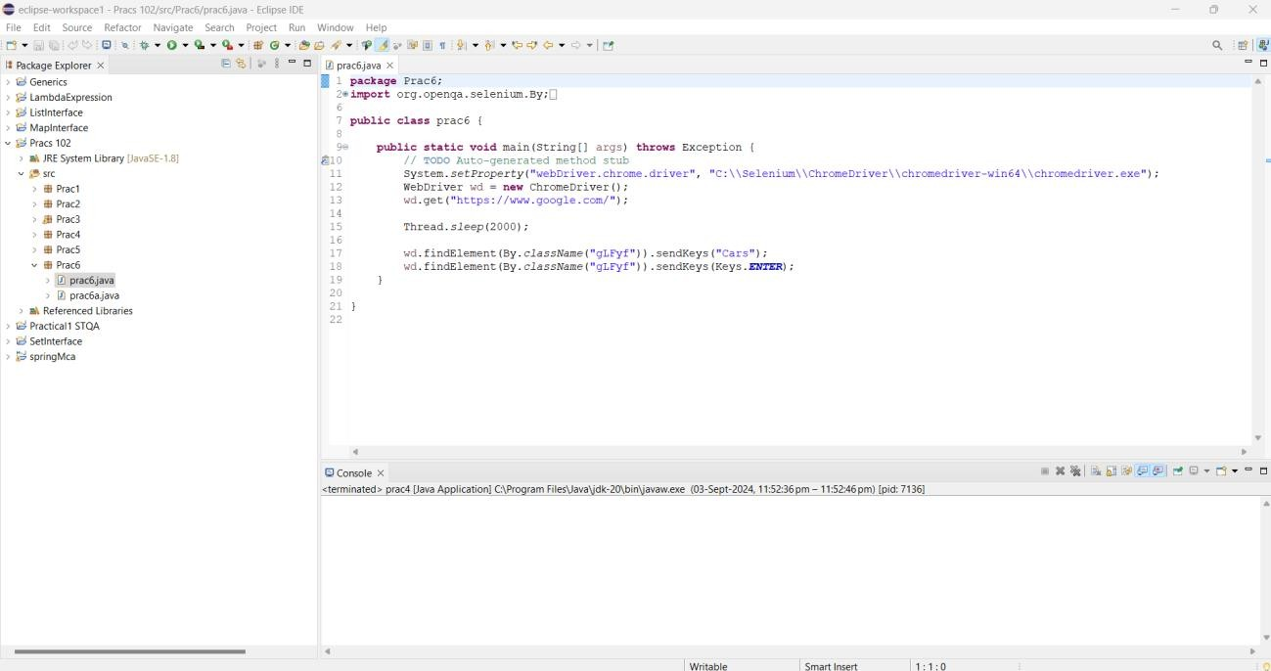}

## Output:

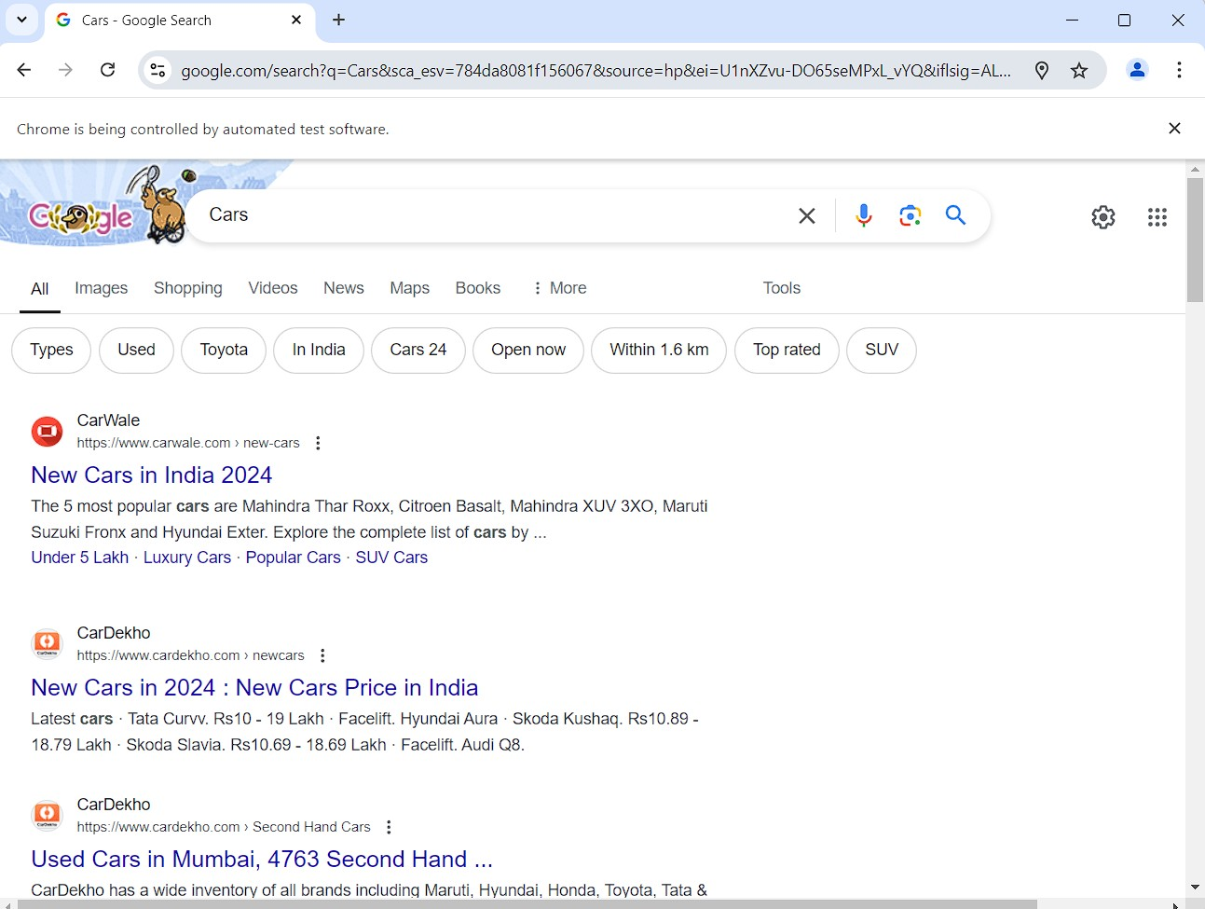

**Code:**

package Prac6;

import org.openqa.selenium.By; import org.openqa.selenium.Keys;

import org.openqa.selenium.WebDriver;

import org.openqa.selenium.chrome.ChromeDriver; public class prac6a {

public static void main(String[] args) throws Exception {

// TODO Auto-generated method stub System.setProperty("webDriver.chrome.driver",

"C:\\seleniumweb driver\\ChromeDriver\\chromedriver- win64\\chromedriver-win64\\chromedriver.exe");

WebDriver wd = new ChromeDriver(); wd.get("https://[www.bing.com/](http://www.bing.com/)"); Thread.sleep(2000);

wd.findElement(By.className("sb_form_q")).sendKeys("Cars"); wd.findElement(By.className("sb_form_q")).sendKeys(Keys.ENTER);

}

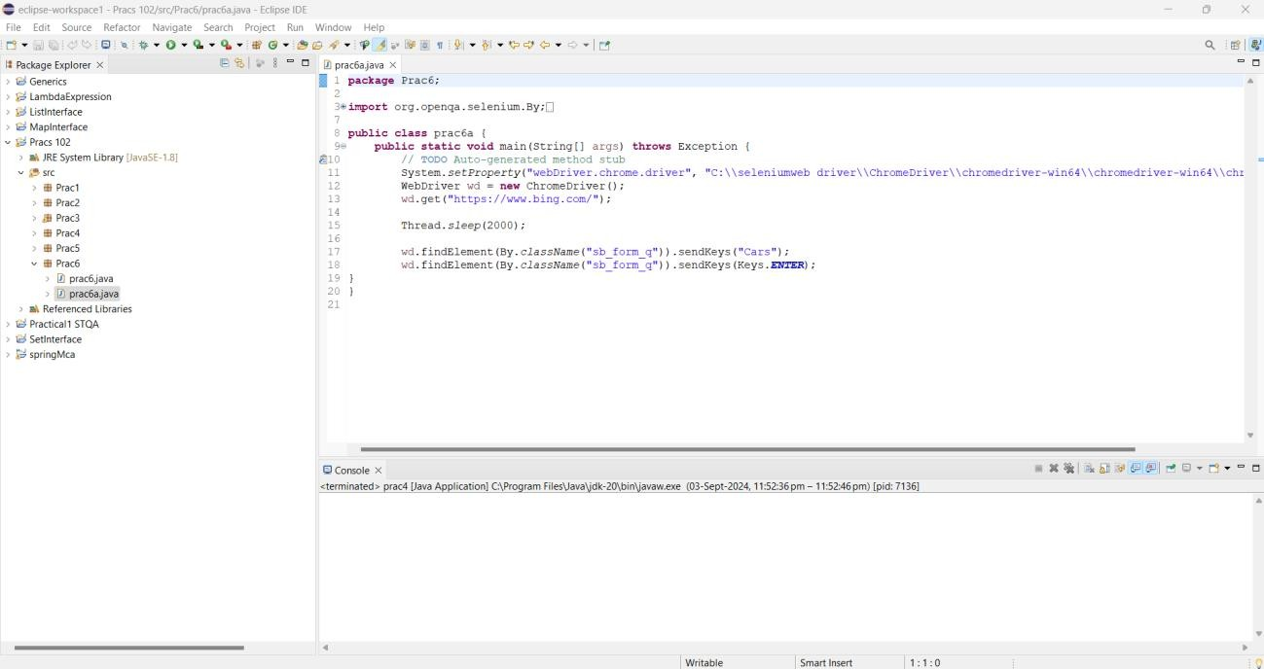}

## Output:

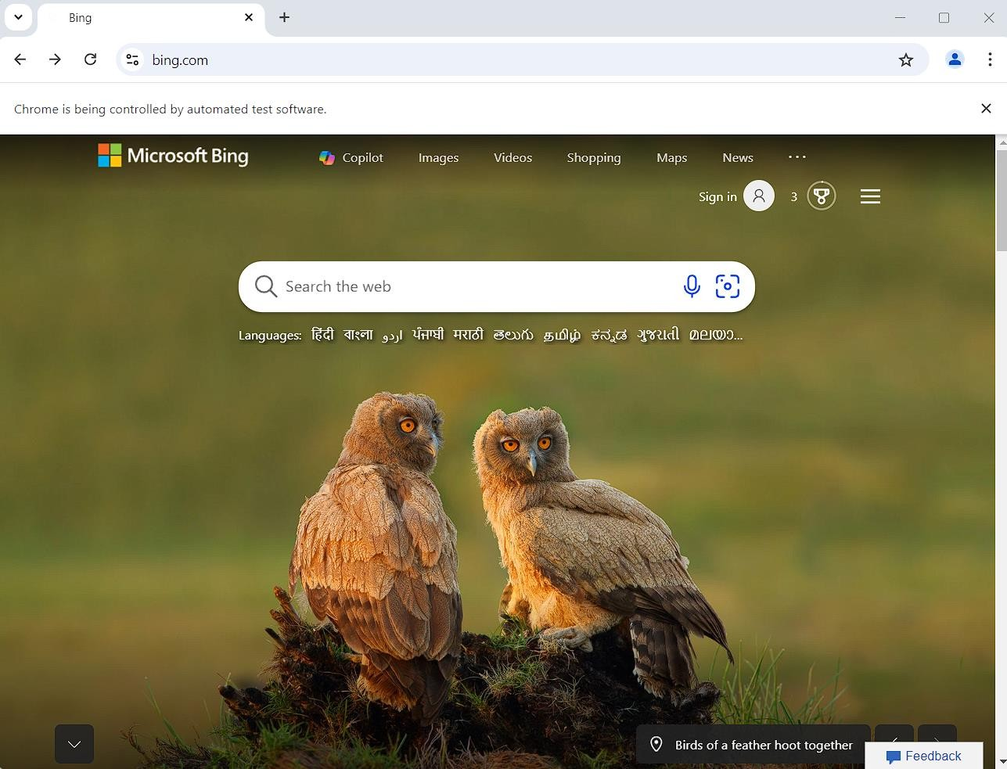

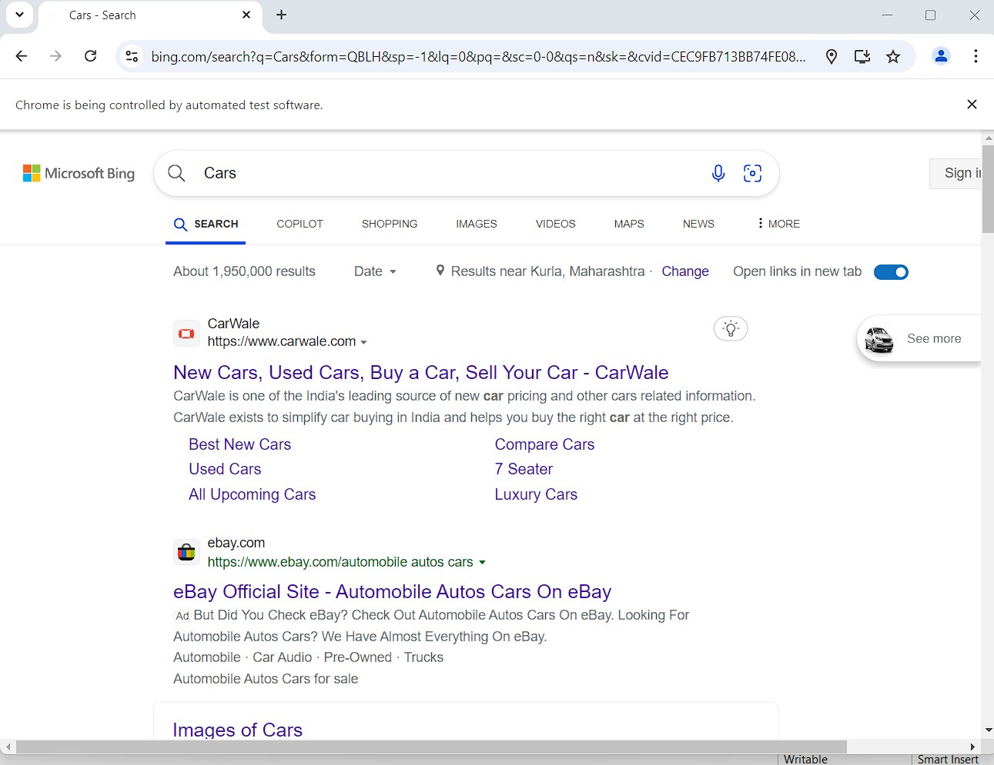

**Practical No 15**

Aim:- Perform regression testing

Theory:-

What is Regression Testing?

REGRESSION TESTING is defined as a type of software testing to confirm that a

recent program or code change has not adversely affected existing features. Regression Testing is nothing but a full or partial selection of already executed test cases which are re-executed to ensure existing functionalities work fine.This testing is done to make sure that new code changes should not have side effects on the existing functionalities. It ensures that the old code still works once the latest code changes are done.

Need of Regression Testing

The Need of Regression Testing mainly arises whenever there is requirement to change the code and we need to test whether the modified code affects the other part of software application or not. Moreover, regression testing is needed, when a new feature is added to the software application and for defect fixing as well as performance issue fixing.

How to do Regression Testing

In order to do Regression Testing process, we need to first debug the code to identify the bugs. Once the bugs are identified, required changes are made to fix it, then the regression testing is done by selecting relevant test cases from the test suite that covers both modified and affected parts of the code.

Software maintenance is an activity which includes enhancements, error corrections,optimization and deletion of existing features. These modifications may cause the system to work incorrectly. Therefore, Regression Testing becomes necessary.

Regression Test Selection

Regression Test Selection is a technique in which some selected test cases from test suite are executed to test whether the modified code affects the software application or not. Test cases are categorized into two parts, reusable test cases which can be used in further regression cycles and obsolete test cases which can not be used in succeeding cycles